UNITED STATES

SECURITIES AND EXCHANGE COMMISSION

Washington, D.C. 20549
________________________________________________

FORM 10-Q

________________________________________________

(Mark One)
- QUARTERLY REPORT PURSUANT TO SECTION 13 OR 15(d) OF THE SECURITIES EXCHANGE ACT OF 1934

For the quarterly period ended July 31, 2020

OR

- TRANSITION REPORT PURSUANT TO SECTION 13 OR 15(d) OF THE SECURITIES EXCHANGE ACT OF 1934

 |  |  | For the transition period from |  |  | to
 |  |  | Commission File Number 1-33913
 |  |  | ________________________________________________
 |  | QUANEX BUILDING PRODUCTS CORPORATION
 |  |  | (Exact name of registrant as specified in its charter)
 |  |  | ________________________________________________
 |  | Delaware |  |  |  | 26-1561397
 | (State or other jurisdiction of |  |  |  |  | (I.R.S. Employer
 | incorporation or organization) |  |  |  |  | Identification No.)
 |  |  | 1800 West Loop South, Suite 1500, Houston, Texas 77027
 |  |  | (Address of principal executive offices and zip code)
 |  |  | Registrant’s telephone number, including area code: (713) 961-4600
 |  |  | ________________________________________________
 |  |  | Securities registered pursuant to Section 12(b) of the Act:
 | Title of each class |  |  | Trading Symbol(s) |  |  | Name of each exchange on which registered
Common Stock, par value $0.01 per share |  |  |  | NX |  |  | New York Stock Exchange

Indicate by check mark whether the registrant (1) has filed all reports required to be filed by Section 13 or 15(d) of the Securities Exchange Act of 1934 during the preceding 12 months (or for such shorter period that the registrant was required to file such reports), and (2) has been subject to such filing requirements for the past 90 days. Yes ☒ No ☐

Indicate by check mark whether the registrant has submitted electronically every Interactive Data File required to be submitted and posted pursuant to Rule 405 of Regulation S-T (Section 232.405 of this chapter) during the preceding 12 months (or for such shorter period that the registrant was required to submit such files). Yes ☒ No ☐

Indicate by check mark whether the registrant is a large accelerated filer, an accelerated filer, a non-accelerated filer, a smaller reporting company, or an emerging growth company. See the definitions of “large accelerated filer,” “accelerated filer,” “smaller reporting company,” and "emerging growth company" in Rule 12b-2 of the Exchange Act. (Check one):

Large accelerated filer | ☒ | Accelerated filer
Non-accelerated filer | ☐ (Do not check if a smaller reporting company) | Smaller reporting company
 |  | Emerging growth company

If an emerging growth company, indicate by check mark if the registrant has elected not to use the extended transition period for complying with any new or revised financial accounting standards provided pursuant to Section 13(a) of the Securities Act.

Indicate by check mark whether the registrant is a shell company (as defined in Rule 12b-2 of the Exchange Act). Yes ☐ No ☒ The number of shares outstanding of the registrant's Common Stock as of September 1, 2020 was 32,805,438.

☐

☐

☐

☐

PART I.

Item 1:

Item 2:

Item 3:

Item 4:

PART II.

Item 1A:

Item 6:

 | QUANEX BUILDING PRODUCTS CORPORATION
 |  |  | INDEX
FINANCIAL INFORMATION |  |  |  |  |  |  |  | 1
Financial Statements (Unaudited) |  |  |  |  |  |  |  | 1
Condensed Consolidated Balance Sheets – July 31, 2020 and October 31, 2019 |  |  |  |  |  |  |  | 1
Condensed Consolidated Statements of Income (Loss) – Three and Nine Months Ended July 31, 2020 and 2019 |  |  |  |  |  |  |  | 2
Condensed Consolidated Statements of Comprehensive Income (Loss) - Three and Nine Months Ended July 31, 2020 and 2019 |  |  |  |  |  |  |  | 3
Condensed Consolidated Statements of Cash Flows – Nine Months Ended July 31, 2020 and 2019 |  |  |  |  |  |  |  | 4
Condensed Consolidated Statement of Stockholders’ Equity – Nine Months Ended July 31, 2020 and 2019 |  |  |  |  |  |  |  | 5
Notes to Unaudited Condensed Consolidated Financial Statements |  |  |  |  |  |  |  | 7
Management’s Discussion and Analysis of Financial Condition and Results of Operations |  |  |  |  |  |  |  | 28
Quantitative and Qualitative Disclosures About Market Risk |  |  |  |  |  |  |  | 41
Controls and Procedures |  |  |  |  |  |  |  | 42
OTHER INFORMATION |  |  |  |  |  |  |  | 43
Risk Factors |  |  |  |  |  |  |  | 43
Exhibits |  |  |  |  |  |  |  | 43

Table of Contents

PART I. FINANCIAL INFORMATION

Item 1. Financial Statements

QUANEX BUILDING PRODUCTS CORPORATION

CONDENSED CONSOLIDATED BALANCE SHEETS

(Unaudited)

 |  | July 31, |  |  | October 31,
 |  | 2020 |  |  | 2019
 |  | (In thousands, except share
 |  | amounts)
ASSETS
Current assets:
Cash and cash equivalents | $ | 41,073 |  | $ | 30,868
Accounts receivable, net of allowance for doubtful accounts of $344 and $393 |  | 84,479 |  |  | 82,946
Inventories, net |  | 63,939 |  |  | 67,159
Prepaid and other current assets |  | 7,930 |  |  | 9,353
Total current assets |  | 197,421 |  |  | 190,326
Property, plant and equipment, net of accumulated depreciation of $334,664 and $317,568 |  | 186,830 |  |  | 193,600
Operating lease right-of-use assets |  | 49,644 |  |  | —
Goodwill |  | 146,932 |  |  | 145,563
Intangible assets, net |  | 96,957 |  |  | 107,297
Other assets |  | 9,007 |  |  | 8,324
Total assets | $ | 686,791 |  | $ | 645,110
LIABILITIES AND STOCKHOLDERS' EQUITY
Current liabilities:
Accounts payable | $ | 58,676 |  | $ | 63,604
Accrued liabilities |  | 33,916 |  |  | 39,221
Income taxes payable |  | 6,350 |  |  | 6,183
Current maturities of long-term debt |  | 690 |  |  | 746
Current operating lease liabilities |  | 7,307 |  |  | —
Total current liabilities |  | 106,939 |  |  | 109,754
Long-term debt |  | 152,062 |  |  | 156,414
Noncurrent operating lease liabilities |  | 42,740 |  |  | —
Deferred pension and postretirement benefits |  | 11,375 |  |  | 13,322
Deferred income taxes |  | 20,507 |  |  | 19,363
Other liabilities |  | 13,230 |  |  | 16,070
Total liabilities |  | 346,853 |  |  | 314,923
Commitments and contingencies
Stockholders’ equity:
Preferred stock, no par value, shares authorized 1,000,000; issued and outstanding - none |  | — |  |  | —
Common stock, $0.01 par value, shares authorized 125,000,000; issued 37,304,366 and 37,370,402, respectively; outstanding 32,801,738 and |  | 373 |  |  | 374
33,021,789, respectively |  | 373 |  |  | 374
Additional paid-in-capital |  | 253,144 |  |  | 254,673
Retained earnings |  | 193,989 |  |  | 185,703
Accumulated other comprehensive loss |  | (28,819) |  |  | (33,817)
Less: Treasury stock at cost, 4,502,628 and 4,348,613 shares, respectively |  | (78,749) |  |  | (76,746)
Total stockholders’ equity |  | 339,938 |  |  | 330,187
Total liabilities and stockholders' equity | $ | 686,791 |  | $ | 645,110

The accompanying notes are an integral part of the financial statements.

1

Table of Contents

QUANEX BUILDING PRODUCTS CORPORATION

CONDENSED CONSOLIDATED STATEMENTS OF INCOME (LOSS)

(Unaudited)

 |  | Three Months Ended |  |  |  |  |  | Nine Months Ended
 |  | July 31, |  |  |  |  |  | July 31,
 |  | 2020 |  |  | 2019 |  |  | 2020 |  |  | 2019
 |  |  |  |  | (In thousands, except per share amounts)
Net sales | $ | 212,096 |  | $ | 238,461 |  | $ | 596,168 |  | $ | 653,472
Cost and expenses:
Cost of sales (excluding depreciation and amortization) |  | 162,427 |  |  | 181,357 |  |  | 469,586 |  |  | 511,292
Selling, general and administrative |  | 21,973 |  |  | 25,718 |  |  | 62,818 |  |  | 77,466
Restructuring charges |  | 73 |  |  | 94 |  |  | 477 |  |  | 281
Depreciation and amortization |  | 11,060 |  |  | 12,182 |  |  | 35,851 |  |  | 37,158
Asset impairment charges |  | — |  |  | — |  |  | — |  |  | 29,978
Operating income (loss) |  | 16,563 |  |  | 19,110 |  |  | 27,436 |  |  | (2,703)
Non-operating (expense) income:
Interest expense |  | (1,165) |  |  | (2,570) |  |  | (4,310) |  |  | (7,614)
Other, net |  | (220) |  |  | 259 |  |  | 116 |  |  | 461
Income (loss) before income taxes |  | 15,178 |  |  | 16,799 |  |  | 23,242 |  |  | (9,856)
Income tax expense |  | (4,345) |  |  | (4,958) |  |  | (6,898) |  |  | (5,926)
Net income (loss) | $ | 10,833 |  | $ | 11,841 |  | $ | 16,344 |  | $ | (15,782)
Basic earnings (loss) per common share | $ | 0.33 |  | $ | 0.36 |  | $ | 0.50 |  | $ | (0.48)
Diluted earnings (loss) per common share: | $ | 0.33 |  | $ | 0.36 |  | $ | 0.50 |  | $ | (0.48)
Weighted-average common shares outstanding:
Basic |  | 32,610 |  |  | 32,899 |  |  | 32,716 |  |  | 32,984
Diluted |  | 32,739 |  |  | 33,162 |  |  | 32,845 |  |  | 32,984
Cash dividends per share | $ | 0.08 |  | $ | 0.08 |  | $ | 0.24 |  | $ | 0.24

The accompanying notes are an integral part of the financial statements.

2

Table of Contents

QUANEX BUILDING PRODUCTS CORPORATION CONDENSED CONSOLIDATED STATEMENTS OF COMPREHENSIVE INCOME (LOSS) (Unaudited)

 |  | Three Months Ended |  |  |  |  |  | Nine Months Ended
 |  | July 31, |  |  |  |  |  | July 31,
 |  | 2020 |  |  | 2019 |  |  | 2020 |  |  | 2019
 |  |  |  |  | (In thousands)
Net income (loss) | $ | 10,833 |  | $ | 11,841 |  | $ | 16,344 |  | $ | (15,782)
Other comprehensive income:
Foreign currency translation gain (loss) |  | 7,344 |  |  | (10,147) |  |  | 3,088 |  |  | (7,565)
Change in pension from net unamortized gain (loss) adjustment (pretax) |  | — |  |  | — |  |  | 2,519 |  |  | (11)
Change in pension from net unamortized gain (loss) adjustment tax (expense) benefit |  | — |  |  | — |  |  | (609) |  |  | 7
Other comprehensive income (loss) |  | 7,344 |  |  | (10,147) |  |  | 4,998 |  |  | (7,569)
Comprehensive income (loss) | $ | 18,177 |  | $ | 1,694 |  | $ | 21,342 |  | $ | (23,351)

The accompanying notes are an integral part of the financial statements.

3

Table of Contents

QUANEX BUILDING PRODUCTS CORPORATION

CONDENSED CONSOLIDATED STATEMENTS OF CASH FLOWS

(Unaudited)

 |  | Nine Months Ended
 |  | July 31,
 |  | 2020 |  |  | 2019
 |  | (In thousands)
Operating activities:
Net income (loss) | $ | 16,344 |  | $ | (15,782)
Adjustments to reconcile net income (loss) to cash provided by operating activities:
Depreciation and amortization |  | 35,851 |  |  | 37,158
Stock-based compensation |  | 513 |  |  | 1,424
Deferred income tax |  | 438 |  |  | 1,930
Asset impairment charges |  | — |  |  | 29,978
Other, net |  | 762 |  |  | 1,724
Changes in assets and liabilities:
(Increase) decrease in accounts receivable |  | (1,852) |  |  | 323
Decrease (increase) in inventory |  | 3,553 |  |  | (14,747)
Decrease (increase) in other current assets |  | 1,218 |  |  | (1,022)
(Decrease) increase in accounts payable |  | (1,878) |  |  | 1,562
Decrease in accrued liabilities |  | (7,611) |  |  | (15,366)
Increase in income taxes payable |  | 107 |  |  | 396
Increase in deferred pension and postretirement benefits |  | 573 |  |  | 2,351
Decrease in other long-term liabilities |  | (181) |  |  | (143)
Other, net |  | (276) |  |  | 250
Cash provided by operating activities |  | 47,561 |  |  | 30,036
Investing activities:
Capital expenditures |  | (20,673) |  |  | (16,984)
Proceeds from disposition of capital assets |  | 131 |  |  | 315
Cash used for investing activities |  | (20,542) |  |  | (16,669)
Financing activities:
Borrowings under credit facilities |  | 114,500 |  |  | 66,500
Repayments of credit facility borrowings |  | (119,000) |  |  | (84,000)
Repayments of other long-term debt |  | (791) |  |  | (1,102)
Common stock dividends paid |  | (7,910) |  |  | (7,990)
Issuance of common stock |  | 2,954 |  |  | 2,710
Payroll tax paid to settle shares forfeited upon vesting of stock |  | (454) |  |  | (330)
Purchase of treasury stock |  | (6,693) |  |  | (6,336)
Cash used for financing activities |  | (17,394) |  |  | (30,548)
Effect of exchange rate changes on cash and cash equivalents |  | 580 |  |  | (1,171)
Increase (decrease) in cash and cash equivalents |  | 10,205 |  |  | (18,352)
Cash and cash equivalents at beginning of period |  | 30,868 |  |  | 29,003
Cash and cash equivalents at end of period | $ | 41,073 |  | $ | 10,651

The accompanying notes are an integral part of the financial statements.

4

Table of Contents

QUANEX BUILDING PRODUCTS CORPORATION

CONDENSED CONSOLIDATED STATEMENTS OF STOCKHOLDERS’ EQUITY

(Unaudited)

 | Common | Additional | Retained | Accumulated | Treasury | Total
Nine Months Ended July 31, 2020 | Common | Paid-in | Retained | Other | Treasury | Stockholders’
Nine Months Ended July 31, 2020 | Stock | Capital | Earnings | Comprehensive Loss | Stock | Equity

(In thousands, no per share amounts shown except in verbiage)

Balance at October 31, 2019 | $ | 374 |  | $ | 254,673 |  | $ | 185,703 |  | $ | (33,817) |  | $ | (76,746) |  | $ | 330,187
Net income |  | — |  |  | — |  |  | 10 |  |  | — |  |  | — |  |  | 10
Foreign currency translation adjustment |  | — |  |  | — |  |  | — |  |  | 2,743 |  |  | — |  |  | 2,743
Common dividends ($0.08 per share) |  | — |  |  | — |  |  | (2,659) |  |  | — |  |  | — |  |  | (2,659)
Purchase of treasury stock |  | — |  |  | — |  |  | — |  |  | — |  |  | (4,639) |  |  | (4,639)
Change in pension from net unamortized gain (net of tax expense of
$609) |  | — |  |  | — |  |  | — |  |  | 1,910 |  |  | — |  |  | 1,910
Stock-based compensation activity:
Stock-based compensation benefit |  | — |  |  | (239) |  |  | — |  |  | — |  |  | — |  |  | (239)
Stock options exercised |  | — |  |  | 92 |  |  | (159) |  |  | — |  |  | 3,142 |  |  | 3,075
Restricted stock awards granted |  | — |  |  | (1,082) |  |  | 94 |  |  | — |  |  | 988 |  |  | —
Performance share awards vested |  | — |  |  | (495) |  |  | — |  |  | — |  |  | 495 |  |  | —
Other |  | (1) |  |  | (454) |  |  | — |  |  | — |  |  | — |  |  | (455)
Balance at January 31, 2020 | $ | 373 |  | $ | 252,495 |  | $ | 182,989 |  | $ | (29,164) |  | $ | (76,760) |  | $ | 329,933
Net income |  | — |  |  | — |  |  | 5,501 |  |  | — |  |  | — |  |  | 5,501
Foreign currency translation adjustment |  | — |  |  | — |  |  | — |  |  | (6,999) |  |  | — |  |  | (6,999)
Common dividends ($0.08 per share) |  | — |  |  | — |  |  | (2,628) |  |  | — |  |  | — |  |  | (2,628)
Purchase of treasury stock |  | — |  |  | — |  |  | — |  |  | — |  |  | (2,054) |  |  | (2,054)
Stock-based compensation activity:
Expense related to stock-based compensation |  | — |  |  | 325 |  |  | — |  |  | — |  |  | — |  |  | 325
Stock options exercised |  | — |  |  | (38) |  |  | (83) |  |  | — |  |  | — |  |  | (121)
Restricted stock awards granted |  | — |  |  | (65) |  |  | — |  |  | — |  |  | 65 |  |  | —
Balance at April 30, 2020 | $ | 373 |  | $ | 252,717 |  | $ | 185,779 |  | $ | (36,163) |  | $ | (78,749) |  | $ | 323,957
Net income |  | — |  |  | — |  |  | 10,833 |  |  | — |  |  | — |  |  | 10,833
Foreign currency translation adjustment |  | — |  |  | — |  |  | — |  |  | 7,344 |  |  | — |  |  | 7,344
Common dividends ($0.08 per share) |  | — |  |  | — |  |  | (2,623) |  |  | — |  |  | — |  |  | (2,623)
Stock-based compensation activity:
Expense related to stock-based compensation |  | — |  |  | 427 |  |  | — |  |  | — |  |  | — |  |  | 427
Balance at July 31, 2020 | $ | 373 |  | $ | 253,144 |  | $ | 193,989 |  | $ | (28,819) |  | $ | (78,749) |  | $ | 339,938
 |  |  |  |  | 5

Table of Contents

 | Common | Additional | Retained | Accumulated | Treasury | Total
Nine Months Ended July 31, 2019 | Common | Paid-in | Retained | Other | Treasury | Stockholders’
Nine Months Ended July 31, 2019 | Stock | Capital | Earnings | Comprehensive Loss | Stock | Equity

(In thousands, no per share amounts shown except in verbiage)

Balance at October 31, 2018 | $ | 374 |  | $ | 254,678 |  | $ | 243,904 |  | $ | (30,705) |  | $ | (73,029) |  | $ | 395,222
Net loss |  | — |  |  | — |  |  | (3,649) |  |  | — |  |  | — |  |  | (3,649)
Foreign currency translation adjustment |  | — |  |  | — |  |  | — |  |  | 4,066 |  |  | — |  |  | 4,066
Common dividends ($0.08 per share) |  | — |  |  | — |  |  | (2,675) |  |  | — |  |  | — |  |  | (2,675)
Purchase of treasury stock |  | — |  |  | — |  |  | — |  |  | — |  |  | (2,016) |  |  | (2,016)
Stock-based compensation activity:
Expense related to stock-based compensation |  | — |  |  | 224 |  |  | — |  |  | — |  |  | — |  |  | 224
Stock options exercised |  | — |  |  | — |  |  | (35) |  |  | — |  |  | 62 |  |  | 27
Restricted stock awards granted |  | — |  |  | (1,649) |  |  | (496) |  |  | — |  |  | 2,145 |  |  | —
Other |  | — |  |  | (322) |  |  | — |  |  | (4) |  |  | — |  |  | (326)
Balance at January 31, 2019 | $ | 374 |  | $ | 252,931 |  | $ | 237,049 |  | $ | (26,643) |  | $ | (72,838) |  | $ | 390,873
Net income |  | — |  |  | — |  |  | (23,974) |  |  | — |  |  | — |  |  | (23,974)
Foreign currency translation adjustment |  | — |  |  | — |  |  | — |  |  | (1,484) |  |  | — |  |  | (1,484)
Common dividends ($0.08 per share) |  | — |  |  | — |  |  | (2,660) |  |  | — |  |  | — |  |  | (2,660)
Purchase of treasury stock |  | — |  |  | — |  |  | — |  |  | — |  |  | (2,686) |  |  | (2,686)
Stock-based compensation activity:
Expense related to stock-based compensation |  | — |  |  | 819 |  |  | — |  |  | — |  |  | — |  |  | 819
Restricted stock awards granted |  | — |  |  | (71) |  |  | (9) |  |  | — |  |  | 80 |  |  | —
Balance at April 30, 2019 | $ | 374 |  | $ | 253,679 |  | $ | 210,406 |  | $ | (28,127) |  | $ | (75,444) |  | $ | 360,888
Net income
Net income |  | — |  |  | — |  |  | 11,841 |  |  | — |  |  | — |  |  | 11,841
Foreign currency translation adjustment |  | — |  |  | — |  |  | — |  |  | (10,147) |  |  | — |  |  | (10,147)
Common dividends ($0.04 per share) |  | — |  |  | — |  |  | (2,655) |  |  | — |  |  | — |  |  | (2,655)
Purchase of treasury stock |  | — |  |  | — |  |  | — |  |  | — |  |  | (1,634) |  |  | (1,634)
Change in pension from net unamortized loss (net of tax expense of $7)
Stock-based compensation activity:
Expense related to stock-based compensation |  | — |  |  | 381 |  |  | — |  |  | — |  |  | — |  |  | 381
Stock options exercised |  | 1 |  |  | — |  |  | (252) |  |  | — |  |  | 2,935 |  |  | 2,684
Other |  | (1) |  |  | (7) |  |  | — |  |  | — |  |  | — |  |  | (8)
Balance at July 31, 2019 | $ | 374 |  | $ | 254,053 |  | $ | 219,340 |  | $ | (38,274) |  | $ | (74,143) |  | $ | 361,350

The accompanying notes are an integral part of the financial statements.

6

Table of Contents

QUANEX BUILDING PRODUCTS CORPORATION

NOTES TO UNAUDITED CONDENSED CONSOLIDATED FINANCIAL STATEMENTS

1. Nature of Operations and Basis of Presentation

Quanex Building Products Corporation is a component supplier to original equipment manufacturers (OEMs) in the building products industry. These components can be categorized as window and door (fenestration) components and kitchen and bath cabinet components. Examples of fenestration components include: (1) energy-efficient flexible insulating glass spacers, (2) extruded vinyl profiles, (3) window and door screens, and (4) precision-formed metal and wood products. We also manufacture cabinet doors and other components for OEMs in the kitchen and bathroom cabinet industry. In addition, we provide certain other non-fenestration components and products, which include solar panel sealants, trim moldings, vinyl decking, fencing, water retention barriers, and conservatory roof components. We have organized our business into three reportable business segments. For additional discussion of our reportable business segments, see Note 12, "Segment Information." We use low-cost, short lead-time production processes and engineering expertise to provide our customers with specialized products for their specific window, door, and cabinet applications. We believe these capabilities provide us with unique competitive advantages. We serve a primary customer base in North America and the United Kingdom (U.K.), and also serve customers in international markets through our operating plants in the U.K. and Germany, as well as through sales and marketing efforts in other countries.

Unless the context indicates otherwise, references to "Quanex", the "Company", "we", "us" and "our" refer to the consolidated business operations of Quanex Building Products Corporation and its subsidiaries.

The accompanying interim condensed consolidated financial statements include the accounts of Quanex Building Products Corporation. All intercompany accounts and transactions have been eliminated in consolidation. These financial statements have been prepared by us, without audit, pursuant to the rules and regulations of the Securities and Exchange Commission (SEC). Certain information and footnote disclosures normally included in financial statements prepared in accordance with accounting principles generally accepted in the United States of America (U.S. GAAP) have been condensed or omitted pursuant to such rules and regulations. The condensed consolidated balance sheet as of October 31, 2019 was derived from audited financial information, but does not include all disclosures required by U.S. GAAP. The accompanying financial statements should be read in conjunction with the audited consolidated financial statements and the notes thereto, included in our Annual Report on Form 10-K for the fiscal year ended October 31, 2019. In our opinion, the accompanying financial statements contain all adjustments (which consist of normal recurring adjustments, except as disclosed herein) necessary to fairly present our financial position, results of operations and cash flows for the interim periods. The results of operations for the periods presented are not necessarily indicative of the results to be expected for the full year or for any future periods.

In preparing financial statements, we make informed judgments and estimates that affect the reported amounts of assets and liabilities as of the date of the financial statements and affect the reported amounts of revenues and expenses during the reporting period. We review our estimates on an on-going basis, including those related to impairment of long lived assets and goodwill, contingencies and income taxes. Changes in facts and circumstances may result in revised estimates and actual results may differ from these estimates.

Revenue from Contracts with Customers

Revenue recognition

We recognize revenue that reflects the consideration we expect to receive for product sales upon transfer to customers. Revenue for product sales is recognized when control of the promised products is actually transferred to our customers, and we expect to be entitled to consideration in exchange for such transfer. We account for a contract when a customer provides us with a firm purchase order that identifies the products to be provided, the payment terms for those services, and when collectability of the consideration due is probable.

Performance obligations

A performance obligation is a promise to provide the customer with a good or service. Our performance obligations include product sales, with each product included in a customer contract being recognized as a separate performance obligation. For contracts with multiple performance obligations, the standalone selling price of each product is generally readily observable.

Revenue from product sales is recognized at a point in time when the product is transferred to the customer, in accordance with the shipping terms, which is generally upon shipment. We estimate a provision for sales returns and warranty allowances to account for product returns related to general returns and product nonconformance.

7

Table of Contents

QUANEX BUILDING PRODUCTS CORPORATION

NOTES TO UNAUDITED CONDENSED CONSOLIDATED FINANCIAL STATEMENTS (continued)

Pricing and sales incentives

Pricing is established at or prior to the time of sale with our customers and we record sales at the agreed-upon net selling price, reflective of current and prospective discounts.

Practical expedients and exemptions

We generally expense incremental costs of obtaining a contract when incurred because the amortization period would be less than one year. Additionally, we do not disclose the value of unsatisfied performance obligations for contracts with an original expected length of one year or less.

Shipping and handling costs

We account for shipping and handling services as fulfillment services; accordingly, freight revenue is combined with the product deliverable rather than being accounted for as a distinct performance obligation within the terms of the agreement. Shipping and handling costs incurred by us for the delivery of goods to customers are considered a cost to fulfill the contract and are included in Cost of sales in the accompanying Condensed Consolidated Statements of Income.

Contract assets and liabilities

Deferred revenue, which is not significant, is recorded when we have remaining unsatisfied performance obligations for which we have received consideration.

Disaggregation of revenue

We produce a wide variety of products that are used in the fenestration industry, including window spacer systems; extruded vinyl products; metal fabricated products; and astragals, thresholds and screens. In addition, we produce certain non-fenestration products, including kitchen and bath cabinet doors and components, flooring and trim moldings, solar edge tape, plastic decking, fencing, water retention barriers, conservatory roof components, and other products.

The following table summarizes our product sales for the three and nine months ended July 31, 2020 and 2019 into groupings by segment which we believe depicts how the nature, amount, timing and uncertainty of our revenues and cash flows are affected by economic factors. For further details regarding our results by segment, refer to Note 12, “Segment Information”.

8

Table of Contents

QUANEX BUILDING PRODUCTS CORPORATION

NOTES TO UNAUDITED CONDENSED CONSOLIDATED FINANCIAL STATEMENTS (continued)

 |  | Three Months Ended |  |  |  |  |  | Nine Months Ended
 |  | July 31, |  |  |  |  |  | July 31,
 |  | 2020 |  |  | 2019 |  |  | 2020 |  |  | 2019
 |  |  |  |  | (In thousands)
North American Fenestration:
United States - fenestration | $ | 109,455 |  | $ | 119,481 |  | $ | 302,094 |  | $ | 312,509
International - fenestration |  | 6,696 |  |  | 7,172 |  |  | 19,284 |  |  | 23,474
United States - non-fenestration |  | 4,845 |  |  | 3,982 |  |  | 13,779 |  |  | 12,290
International - non-fenestration |  | 1,390 |  |  | 5,624 |  |  | 6,275 |  |  | 12,381
 | $ | 122,386 |  | $ | 136,259 |  | $ | 341,432 |  | $ | 360,654
European Fenestration:
International - fenestration | $ | 31,904 |  | $ | 36,342 |  | $ | 87,732 |  | $ | 102,038
International - non-fenestration |  | 6,361 |  |  | 7,984 |  |  | 16,498 |  |  | 19,165
 | $ | 38,265 |  | $ | 44,326 |  | $ | 104,230 |  | $ | 121,203
North American Cabinet Components:
United States - fenestration | $ | 2,666 |  | $ | 3,561 |  | $ | 8,461 |  | $ | 9,909
United States - non-fenestration |  | 48,849 |  |  | 54,512 |  |  | 142,838 |  |  | 163,694
International - non-fenestration |  | 410 |  |  | 616 |  |  | 1,335 |  |  | 1,774
 | $ | 51,925 |  | $ | 58,689 |  | $ | 152,634 |  | $ | 175,377
Unallocated Corporate & Other
Eliminations | $ | (480) |  | $ | (813) |  | $ | (2,128) |  | $ | (3,762)
 | $ | (480) |  | $ | (813) |  | $ | (2,128) |  | $ | (3,762)
Net sales | $ | 212,096 |  | $ | 238,461 |  | $ | 596,168 |  | $ | 653,472

Restructuring

We accrue one-time severance costs pursuant to an approved plan of restructuring at the communication date, when affected employees have been notified of the potential severance and sufficient information has been provided for the employee to calculate severance benefits, in the event the employee is involuntarily terminated. In addition, we accrue costs associated with the termination of contractual commitments including operating leases at the time the lease is terminated pursuant to the lease provisions or in accordance with another agreement with the landlord. Otherwise, we continue to recognize operating lease expense through the cease-use date. After the cease-use date, we determine if our operating lease payments are at market. We assume sublet of the facility at the market rate. To the extent our lease obligations exceed the fair value rentals, we discount to arrive at the present value and record a liability. If the facility is not sublet, we expense the amount of the rental in the current period. For other costs directly related to the restructuring effort, such as equipment moving costs, we expense in the period incurred.

During the year ended October 31, 2019, our North American Cabinet Components segment experienced declines in current and forecasted demand as a result of an industry-wide shift from semi-custom cabinets to stock cabinets, and received notice about a change in strategy at one of our large customers that may result in lower sales volumes in the future. As a result, during the first quarter of fiscal 2020, we began to restructure our operations within that segment by announcing the closure of one of our plants. We incurred expenses for severance, equipment moves, and other exit activities of $0.3 million related to this plant closure during the nine months ended July 31, 2020 and we may incur costs related to additional restructuring activities in future periods.

COVID-19 Impact

On March 11, 2020, the World Health Organization (WHO) declared the outbreak of COVID-19 as a global pandemic and advised aggressive containment action. In response to this declaration and the rapid global spread of COVID-19, national, state, and local governments have taken extraordinary and continuously evolving measures to limit the outbreak and spread of the virus, including travel bans, quarantines, "stay-at-home" orders and similar mandates imposing varying degrees of restrictions on social and non-essential commercial activity to promote social distancing. Measures providing for business shutdowns generally exclude certain essential services commonly including critical infrastructure such as construction and the

9

Table of Contents

QUANEX BUILDING PRODUCTS CORPORATION

NOTES TO UNAUDITED CONDENSED CONSOLIDATED FINANCIAL STATEMENTS (continued)

businesses that support that critical infrastructure. To date, we have not experienced significant challenges or expenses implementing crisis management plans intended to meet government requirements for containment and prevention.

The COVID-19 pandemic and actions taken in response thereto are continuing to have an adverse effect on many sectors of the economy. We initially reduced operating schedules and implemented furloughs to balance production and demand, but all facilities were reopened during May 2020. However, the duration and severity of the COVID-19 pandemic, the actions to contain the pandemic and treat its impacts, and the effects on our operations are highly uncertain and cannot be predicted at this time. Therefore, while we expect some negative impacts on our business, results of operations, cash flows and financial position, the overall financial impact cannot be reasonably estimated at this time.

Additionally, in response to the current business environment as impacted by COVID-19, we are reducing capital expenditures and discretionary spending as well as closely monitoring our working capital needs.

As a result of the economic and business impact of COVID-19, we may be required to revise certain accounting estimates and judgments such as, but not limited to, those related to the valuation of goodwill, intangibles, right-of-use assets, long-lived assets, accounts receivable (including allowances for credit losses), and inventory, which could have a material adverse effect on our financial position and results of operations.

2. Leases

Effective November 1, 2019, we adopted Accounting Standards Codification Topic 842, "Leases" (ASC Topic 842), which requires leases to be recognized on the balance sheet. We recognize a right-of-use (ROU) asset and lease liability for each operating and finance lease with a contractual term greater than 12 months at the time of lease inception. We include ROU assets and lease liabilities for leases that exist within other contracts. Leases with an original term of 12 months or less are not recognized on the balance sheet, and the rent expense related to those short-term leases is recognized over the lease term. We do not account for lease and non-lease (e.g. common area maintenance) components of contracts separately for any underlying asset class.

We lease certain manufacturing plants, warehouses, office space, vehicles and equipment under finance and operating leases. Lease commencement occurs on the date we take possession or control of the property or equipment. Original terms for our real estate-related leases are generally between five and twenty years. Original terms for equipment-related leases, primarily manufacturing equipment and vehicles, are generally between one and ten years. Some of our leases also include rental escalation clauses. Renewal options are included in the determination of lease payments when management determines the options are reasonably certain of exercise, considering financial performance, strategic importance and/or invested capital.

If readily determinable, the rate implicit in the lease is used to discount lease payments to present value; however, substantially all of our leases do not provide a readily determinable implicit rate. When the implicit rate is not determinable, our estimated incremental borrowing rate is utilized, determined on a collateralized basis, to discount lease payments based on information available at lease commencement.

Total lease costs recorded include fixed operating lease costs and variable lease costs. Most of our real estate leases require we pay certain expenses, such as common area maintenance costs, of which the fixed portion is included in operating lease costs. We recognize operating lease costs on a straight-line basis over the lease term. In addition to the above costs, variable lease costs are recognized when probable and are not included in determining the present value of our lease liability.

The ROU asset is measured at the initial amount of the lease liability adjusted for lease payments made at or before the lease commencement date and initial direct costs. For operating leases, ROU assets are reduced over the lease term by the recognized straight-line lease expense less the amount of accretion of the lease liability determined using the effective interest method. For finance leases, ROU assets are amortized on a straight-line basis over the shorter of the useful life of the leased asset or the lease term. Interest expense on each finance lease liability is recognized utilizing the effective interest method. ROU assets are tested for impairment in the same manner as long-lived assets. Additionally, we monitor for events or changes in circumstances that may require a reassessment of one of our leases and determine if a remeasurement is required.

The table below presents the lease-related assets and liabilities recorded on the balance sheet at July 31, 2020 (in thousands):

10

Table of Contents

QUANEX BUILDING PRODUCTS CORPORATION

NOTES TO UNAUDITED CONDENSED CONSOLIDATED FINANCIAL STATEMENTS (continued)

Leases |  | Classification |  |  | July 31, 2020
Assets
Operating lease assets |  | Operating lease right-of-use assets |  | $ | 49,644
Finance lease assets |  | Property, plant and equipment (less accumulated depreciation of $821) |  |  | 14,960
Total lease assets |  |  |  | $ | 64,604
Liabilities
Current
Operating |  | Current operating lease liabilities |  | $ | 7,307
Finance |  | Current maturities of long-term debt |  |  | 961
Noncurrent
Operating |  | Noncurrent operating lease liabilities |  |  | 42,740
Finance |  | Long-term debt |  |  | 14,637
Total lease liabilities |  |  |  | $ | 65,645

The table below presents the components of the lease costs for the three and nine months ended July 31, 2020 (in thousands):

Three Months Ended Nine Months Ended

July 31, 2020 July 31, 2020

Components of lease costs

Operating lease cost

Finance lease cost

Amortization of leased assets

Interest on lease liabilities

Variable lease costs

Total lease cost

$ | 2,243 | $ | 6,464
 | 285 |  | 899
 | 136 |  | 418
 | 207 |  | 535
$ | 2,871 | $ | 8,316

The table below presents supplemental cash flow information related to leases for the six months ended July 31, 2020 (in thousands):

 |  | Nine Months Ended
 |  | July 31, 2020
Supplemental Cash Flow Information
Cash paid for amounts included in the measurement of lease liabilities:
Finance leases - financing cash flows | $ | 857
Finance leases - operating cash flows | $ | 418
Operating leases - operating cash flows | $ | 6,400
Right-of-use assets obtained in exchange for lease liabilities
Operating leases | $ | 15,331
Finance Leases | $ | 398

The table below presents the weighted average remaining lease terms and weighted average discount rates for the Company's leases as of July 31, 2020:

11

Table of Contents

QUANEX BUILDING PRODUCTS CORPORATION

NOTES TO UNAUDITED CONDENSED CONSOLIDATED FINANCIAL STATEMENTS (continued)

 |  |  |  |  |  | July 31, 2020
 | Weighted average remaining lease term (in years)
 | Operating leases |  |  |  |  | 8.2
 | Financing leases |  |  |  |  | 15.5
 | Weighted average discount rate
 | Operating leases |  |  |  |  | 3.62 %
 | Financing leases |  |  |  |  | 3.62 %
 | The table below presents the maturity of the lease liabilities as of July 31, 2020 (in thousands):
 |  | Operating Leases |  |  |  | Finance Leases
 |  |  | (in thousands)
 | 2020 (remaining three months) | $ | 2,271 | $ |  | 378
2021 |  |  | 8,762 |  |  | 1,510
 | 2022 |  | 8,028 |  |  | 1,463
2023 |  |  | 7,592 |  |  | 1,364
 | 2024 |  | 6,816 |  |  | 1,260
 | Thereafter |  | 24,292 |  |  | 14,114
 | Total lease payments |  | 57,761 |  |  | 20,089
 | Less: present value discount |  | 7,714 |  |  | 4,491
 | Total lease liabilities | $ | 50,047 | $ |  | 15,598

As a result of the adoption of ASC Topic 842, we are required to present future minimum lease payments for operating and financing obligations having initial or remaining non-cancelable lease terms in excess of one year. These future minimum lease payments were previously disclosed in our 2019 Annual Report on Form 10-K and accounted for under previous lease guidance. Commitments as of October 31, 2019 were as follows:

 | Operating Leases |  |  |  | Capital Leases
 |  | (in thousands)
2020 | $ | 9,121 |  | $ | 1,020
2021 |  | 6,981 |  |  | 810
2022 |  | 6,012 |  |  | 815
2023 |  | 5,506 |  |  | 973
2024 |  | 4,699 |  |  | 713
Thereafter |  | 15,220 |  |  | 11,392
Total |  | 47,539 |  |  | 15,723
Less: amount representing interest |  |  |  |  | 5,064
Present value of minimum lease payments |  |  |  |  | 10,659

12

Table of Contents

QUANEX BUILDING PRODUCTS CORPORATION

NOTES TO UNAUDITED CONDENSED CONSOLIDATED FINANCIAL STATEMENTS (continued)

3. Inventories

Inventories consisted of the following at July 31, 2020 and October 31, 2019:

 | July 31, |  |  |  | October 31,
 | 2020 |  |  |  | 2019
 |  | (In thousands)
Raw materials | $ | 35,205 |  | $ | 32,818
Finished goods and work in process |  | 33,418 |  |  | 35,538
Supplies and other |  | 2,470 |  |  | 2,593
Total |  | 71,093 |  |  | 70,949
Less: Inventory reserves |  | 7,154 |  |  | 3,790
Inventories, net | $ | 63,939 |  | $ | 67,159

Fixed costs related to excess manufacturing capacity, if any, have been expensed in the period they were incurred and, therefore, are not capitalized into inventory.

4. Goodwill and Intangible Assets

Goodwill

The change in the carrying amount of goodwill for the nine months ended July 31, 2020 was as follows:

 |  | Nine Months Ended
 |  | July 31, 2020
 |  | (In thousands)
Beginning balance as of November 1, 2019 | $ | 145,563
Foreign currency translation adjustment |  | 1,369
Balance as of the end of the period | $ | 146,932

During the year ended October 31, 2019, we recorded impairment charges of $74.6 million associated with our NA Cabinet Components segment, which reduced the goodwill balance applicable to this reporting unit from $113.7 million to $39.1 million. Our other reporting units were not deemed to be impaired at our annual goodwill impairment testing date, August 31, 2019. During the three months ended April 30, 2020, we determined the WHO's characterization of the outbreak of COVID-19 as a global pandemic was a triggering event which could indicate that the carrying value of our goodwill was no longer greater than the fair value. As a result of this determination, we performed a qualitative assessment for each of the five goodwill reportable units. As a result of this analysis, we determined that our goodwill was not more likely than not impaired and no quantitative assessment was necessary. During the three months ended July 31, 2020, we determined that there were no further triggering events related to the impacts of COVID-19 or any other areas of our operations. However, the long term effects of the COVID-19 pandemic on the demand and pricing of our products may result in future impairment charges. For a summary of the change in the carrying amount of goodwill by segment, see Note 12, "Segment Information."

Identifiable Intangible Assets

Amortizable intangible assets consisted of the following as of July 31, 2020 and October 31, 2019:

 |  | July 31, 2020 |  |  |  |  |  | October 31, 2019
 |  | Gross Carrying |  |  | Accumulated |  |  | Gross Carrying |  |  | Accumulated
 |  | Amount |  |  | Amortization |  |  | Amount |  |  | Amortization
 |  |  |  |  | (In thousands)
Customer relationships | $ | 144,418 |  | $ | 68,137 |  | $ | 153,950 |  | $ | 70,103
Trademarks and trade names |  | 55,876 |  |  | 36,833 |  |  | 55,745 |  |  | 35,210
Patents and other technology |  | 22,502 |  |  | 20,869 |  |  | 22,386 |  |  | 19,471
Total | $ | 222,796 |  | $ | 125,839 |  | $ | 232,081 |  | $ | 124,784

During the three months ended July 31, 2020, we retired identifiable intangibles of $9.9 million related to fully amortized customer relationships.

13

Table of Contents

QUANEX BUILDING PRODUCTS CORPORATION

NOTES TO UNAUDITED CONDENSED CONSOLIDATED FINANCIAL STATEMENTS (continued)

We had aggregate amortization expense related to intangible assets for the three and nine months ended July 31, 2020 of $3.4 million and $10.8 million, respectively, and $3.7 million and $11.6 million, respectively, for the comparable prior year periods.

Estimated remaining amortization expense, based on current intangible balances, for each of the fiscal years ending October 31, is as follows (in thousands):

Estimated

Amortization Expense

2020 (remaining three months)

2021

2022

2023

2024

Thereafter

Total

5. Debt and Finance Lease Obligations

Debt consisted of the following at July 31, 2020 and October 31, 2019:

$ | 3,474
 | 12,628
 | 12,004
 | 11,246
 | 10,497
 | 47,108
$ | 96,957

July 31, | October 31,
2020 | 2019
 | (In thousands)

Revolving Credit Facility | $ | 138,000 |  | $ | 142,500
Finance lease obligations and other |  | 15,729 |  |  | 15,865
Unamortized deferred financing fees |  | (977) |  |  | (1,205)
Total debt | $ | 152,752 |  | $ | 157,160
Less: Current maturities of long-term debt |  | 690 |  |  | 746
Long-term debt | $ | 152,062 |  | $ | 156,414

As more fully described in our Annual Report on Form 10-K for the year ended October 31, 2019, on October 18, 2018, we amended and extended our prior credit facility by entering into a $325.0 million revolving credit facility (the “Credit Facility”), with Wells Fargo Bank, National Association, as Agent, Swingline Lender and Issuing Lender, and Bank of America, N.A. serving as Syndication Agent. The Credit Facility has a five-year term, maturing on October 18, 2023, and requires interest payments calculated, at our election and depending upon our Consolidated Leverage Ratio, at either a Base Rate plus an applicable margin or the LIBOR Rate plus an applicable margin. The Credit Facility contains appropriate provisions to substitute LIBOR with a replacement rate upon transition away from LIBOR. These provisions include a temporary conversion of applicable interest for all borrowings outstanding to be calculated as base rate loans until such time that the replacement rate is agreed upon. In addition, we are subject to commitment fees for the unused portion of the Credit Facility.

The applicable margin and commitment fees are outlined in the following table:

Pricing Level | Consolidated Leverage Ratio | Commitment Fee | LIBOR Rate Loans | Base Rate Loans
I | Less than or equal to 1.50 to 1.00 | 0.200% | 1.25% | 0.25%
 | Greater than 1.50 to 1.00, but less than or equal to 2.25
II | to 1.00 | 0.225% | 1.50% | 0.50%
 | Greater than 2.25 to 1.00, but less than or equal to 3.00
III | to 1.00 | 0.250% | 1.75% | 0.75%
IV | Greater than 3.00 to 1.00 | 0.300% | 2.00% | 1.00%

In the event of default, outstanding borrowings would accrue interest at the Default Rate, as defined, whereby the obligations will bear interest at a per annum rate equal to 2% above the total per annum rate otherwise applicable.

14

Table of Contents

QUANEX BUILDING PRODUCTS CORPORATION

NOTES TO UNAUDITED CONDENSED CONSOLIDATED FINANCIAL STATEMENTS (continued)

The Credit Facility contains a: (1) Consolidated Interest Coverage Ratio requirement whereby we must not permit the Consolidated Interest Coverage Ratio, as defined, to be less than 2.25 to 1.00, and (2) Consolidated Leverage Ratio requirement, whereby we must not permit the Consolidated Leverage Ratio, as defined, to be greater than 3.25 to 1.00.

In addition to maintaining these financial covenants, the Credit Facility also limits our ability to enter into certain business transactions, such as to incur indebtedness or liens, to acquire businesses or dispose of material assets, make restricted payments, pay dividends (limited to $20.0 million per year) and other transactions as further defined in the Credit Facility. Substantially all of our domestic assets, with the exception of real property, are utilized as collateral for the Credit Facility.

As of July 31, 2020, we had $138.0 million of borrowings outstanding under the Credit Agreement (reduced by unamortized debt issuance costs of $1.0 million), $4.8 million of outstanding letters of credit and $15.7 million outstanding primarily under finance leases and other debt. We had $182.2 million available for use under the Credit Agreement at July 31, 2020. Outstanding borrowings under the Credit Agreement accrue interest at 1.91% per annum. Our weighted average borrowing rate for borrowings outstanding during the nine months ended July 31, 2020 and 2019 was 2.62% and 4.16%, respectively. We were in compliance with our debt covenants as of July 31, 2020.

During the three months ended July 31, 2020, we repaid $78.0 million of borrowings outstanding on the Credit Facility, including $50.0 million of precautionary borrowings in March 2020 as a result of COVID-19. In the future, we may be required to borrow additional funds in order to be prepared for any unforeseen impacts of the COVID-19 pandemic.

Other Debt Instruments

We maintain certain finance lease obligations related to equipment purchases, vehicles, and warehouse space. Refer to Note 2, "Leases" for further information regarding our finance leases.

6. Retirement Plans

Pension Plan

Our non-contributory, single employer defined benefit pension plan covers a majority of our employees in the U.S. The net periodic pension cost for this plan for the three and nine months ended July 31, 2020 and 2019 was as follows:

 |  | Three Months Ended |  |  |  |  |  | Nine Months Ended
 |  | July 31, |  |  |  |  |  | July 31,
 | 2020 |  |  |  | 2019 |  |  | 2020 |  |  | 2019
 |  |  |  |  | (In thousands)
Service cost | $ | 242 |  | $ | 907 |  | $ | 1,022 |  | $ | 2,722
Interest cost |  | 280 |  |  | 364 |  |  | 853 |  |  | 1,092
Expected return on plan assets |  | (509) |  |  | (494) |  |  | (1,503) |  |  | (1,483)
Amortization of net loss |  | (4) |  |  | 31 |  |  | 200 |  |  | 94
Net periodic pension cost | $ | 9 |  | $ | 808 |  | $ | 572 |  | $ | 2,425

On January 1, 2020, we enacted changes to our pension plan whereby the benefits for all participants were frozen and thereafter those participants will receive increased benefits in the company sponsored defined contribution plan in lieu of participation in a defined benefit plan. As a result of this action, we have remeasured the pension assets and obligations for the pension plan as of December 31, 2019. This resulted in a decrease in our projected benefit obligation and recognition of a net actuarial gain of approximately $2.5 million that was recorded in accumulated other comprehensive income. The decrease in the projected benefit obligation was impacted by our asset performance through December 31, 2019, the impact of the pension plan freeze and an increase in the discount rate since October 31, 2019.

The remeasurement described above is in addition to our annual year-end measurement of the funded status of our benefit plans that we will record as of October 31, 2020. As a result, the change in our pension benefit obligation and net actuarial loss will differ from the $2.5 million discussed above primarily as a result of any changes in interest rates and actual asset performance differs from our expected return on assets during the year.

During September 2019, we contributed $0.7 million to fund our plan, and we expect to make a contribution to our plan in September 2020 of approximately $3.7 million. Other Plans

15

Table of Contents

QUANEX BUILDING PRODUCTS CORPORATION

NOTES TO UNAUDITED CONDENSED CONSOLIDATED FINANCIAL STATEMENTS (continued)

We also have a supplemental benefit plan covering certain executive officers and key employees and a non-qualified deferred compensation plan covering members of the Board of Directors and certain key employees. As of July 31, 2020 and October 31, 2019, our liability under the supplemental benefit plan was approximately $2.4 million and $4.2 million, respectively. As of July 31, 2020 and October 31, 2019, the liability associated with the deferred compensation plan was approximately $3.4 million and $3.8 million, respectively. We record the current portion of liabilities associated with these plans under the caption "Accrued Liabilities," and the long-term portion under the caption "Other Liabilities" in the accompanying condensed consolidated balance sheets.

7. Income Taxes

To determine our income tax expense or benefit for interim periods, consistent with accounting standards, we apply the estimated annual effective income tax rate to year-to-date results. Our estimated annual effective tax rates for the nine months ended July 31, 2020 and 2019 was 27.4% and 24.8%, respectively, excluding discrete items. The 2020 effective rate was primarily impacted by a discrete charge of $0.5 million related to the vesting or exercise of equity-based compensation awards. The 2019 effective rate was primarily impacted by the goodwill impairment charge recorded during the nine months ended July 31, 2019, which did not generate a significant tax benefit.

As of July 31, 2020, our liability for uncertain tax positions (UTP) of $0.6 million relates to certain state tax items regarding the interpretation of tax laws and regulations. Judgment is required in assessing the future tax consequences of events that have been recognized in our financial statements or tax returns. The final outcome of the future tax consequences of legal proceedings, if any, as well as the outcome of competent authority proceedings, changes in regulatory tax laws, or interpretation of those tax laws could impact our financial statements. We are subject to the effect of these matters occurring in various jurisdictions. The disallowance of the UTP would not materially affect the annual effective tax rate. We do not believe any of the UTP at July 31, 2020 will be recognized within the next twelve months.

We evaluate the likelihood of realization of our deferred tax assets by considering both positive and negative evidence. We maintain a valuation allowance for certain state net operating losses which totaled $1.6 million at July 31, 2020 and October 31, 2019.

Final regulations were published by the Internal Revenue Service regarding Uniform Capitalization (UNICAP) that became effective during fiscal 2020. Also, on March 27, 2020, The Coronavirus Aid, Relief, and Economic Security (CARES) Act was signed into law. We are evaluating these regulations but do not believe they will result in a material impact on our consolidated financial statements.

8. Contingencies

Remediation and Environmental Compliance Costs

Under applicable state and federal laws, we may be responsible for, among other things, all or part of the costs required to remove or remediate wastes or hazardous substances at locations we, or our predecessors, have owned or operated. From time to time, we also have been alleged to be liable for all or part of the costs incurred to clean up third-party sites where there might have been an alleged improper disposal of hazardous substances. At present, we are not involved in any such matters.

From time to time, we incur routine expenses and capital expenditures associated with compliance with existing environmental regulations, including control of air emissions and water discharges, and plant decommissioning costs. We have not incurred any material expenses or capital expenditures related to environmental matters during the past three fiscal years, and do not expect to incur a material amount of such costs in fiscal 2020. While we will continue to have future expenditures related to environmental matters, any such amounts are impossible to reasonably estimate at this time. Based upon our experience to date, we do not believe that our compliance with environmental requirements will have a material adverse effect on our operations, financial condition or cash flows.

Litigation

From time to time, we, along with our subsidiaries, are involved in various litigation matters arising in the ordinary course of our business, including those arising from or related to contractual matters, commercial disputes, intellectual property, personal injury, environmental matters, product performance or warranties, product liability, insurance coverage and personnel and employment disputes.

We regularly review with legal counsel the status of all ongoing proceedings, and we maintain insurance against these risks to the extent deemed prudent by our management and to the extent such insurance is available. However, there is no

16

Table of Contents

QUANEX BUILDING PRODUCTS CORPORATION

NOTES TO UNAUDITED CONDENSED CONSOLIDATED FINANCIAL STATEMENTS (continued)

assurance that we will prevail in these matters or that our insurers will accept full coverage of these matters, and we could, in the future, incur judgments, enter into settlements of claims, or revise our expectations regarding the outcome or insurability of matters we face, which could materially impact our results of operations.

We have been and are currently party to multiple claims, some of which are in litigation, relating to alleged defects in a commercial sealant product that was manufactured and sold during the 2000's. While we believe that our product was not defective and that we would prevail in these commercial sealant product claims if taken to trial, the timing, ultimate resolution and potential impact of these claims is not currently determinable. Nevertheless, after taking into account all currently available information, including our defenses, the advice of our counsel, and the extent and currently-expected availability of our existing insurance coverage, we believe that the eventual outcome of these commercial sealant claims will not have a material adverse effect on our overall financial condition, results of operations or cash flows, and we have not recorded any accrual with regard to these claims.

9. Fair Value Measurement of Assets and Liabilities

Fair value is defined as the price that would be received to sell an asset or paid to transfer a liability in an orderly transaction between market participants at the measurement date. The fair value hierarchy distinguishes between (1) market participant assumptions developed based on market data obtained from independent sources (observable inputs) and (2) an entity's own assumptions about market data developed based on the best information available in the circumstances (unobservable inputs). The fair value hierarchy consists of three broad levels, which gives the highest priority to Level 1 and the lowest priority to Level 3. The three levels of the fair value hierarchy are described below:

- Level 1 - Unadjusted quoted prices in active markets that are accessible at the measurement date for identical, unrestricted assets or liabilities.

- Level 2 - Inputs other than quoted prices included within Level 1 that are observable for the asset or liability either directly or indirectly including quoted prices for similar assets or liabilities in active markets; quoted prices for identical or similar assets or liabilities in markets that are not active; inputs other than quoted prices that are observable for the asset or liability (e.g., interest rates) and inputs that are derived principally from or corroborated by observable market data by correlation or other means.

- Level 3 - Inputs that are both significant to the fair value measurement and unobservable.

As of July 31, 2020 and October 31, 2019, foreign currency derivatives were being measured on a recurring basis. Less than $0.1 million of foreign currency derivatives were included in total assets as of October 31, 2019. There were no outstanding foreign currency derivatives as of July 31, 2020. All of our derivative contracts are valued using quoted market prices from brokers or exchanges and are classified within Level 2 of the fair value hierarchy.

Carrying amounts reported on the balance sheet for cash, cash equivalents, accounts receivable and accounts payable approximate fair value due to the short-term maturity of these instruments. Our outstanding debt is variable rate debt that re-prices frequently, thereby limiting our exposure to significant change in interest rate risk. As a result, the fair value of our debt instrument approximates carrying value at July 31, 2020, and October 31, 2019 (Level 2 measurement).

The liability portion of our performance share awards are marked-to-market on a quarterly basis during a three-year vesting period based on market data (Level 2 measurement). For further information, refer to Note 10, "Stock-Based Compensation -Performance Share Awards."

10. Stock-Based Compensation

We have established and maintain an Omnibus Incentive Plan (2020 Plan) that provides for the granting of restricted stock awards, stock options, restricted stock units, performance share awards, performance restricted stock units, and other stock-based and cash-based awards. The 2020 Plan replaced a prior plan (formerly the 2008 Plan) in February 2020. The 2020 Plan is administered by the Compensation and Management Development Committee of the Board of Directors.

The aggregate number of shares of common stock authorized for grant under the 2020 Plan is 3,094,587 as approved by shareholders. Any officer, key employee and/or non-employee director is eligible for awards under the 2020 Plan. We grant restricted stock units to non-employee directors on the first business day of each fiscal year. As approved by the Compensation & Management Development Committee of our Board of Directors annually, we grant a mix of restricted stock awards, restricted stock units, performance shares and/or performance restricted stock units to officers, management and key employees. We also historically granted stock options to certain officers, directors and key employees. Occasionally, we may make additional grants to key employees at other times during the year.

17

Table of Contents

QUANEX BUILDING PRODUCTS CORPORATION

NOTES TO UNAUDITED CONDENSED CONSOLIDATED FINANCIAL STATEMENTS (continued)

Restricted Stock Awards

Restricted stock awards are granted to key employees and officers annually, and typically cliff vest over a three year period with service and continued employment as the only vesting criteria. The recipient of the restricted stock award is entitled to all of the rights of a shareholder, except that the award is nontransferable during the vesting period. The fair value of the restricted stock award is established on the grant date and then expensed over the vesting period resulting in an increase in additional paid-in-capital. Shares are generally issued from treasury stock at the time of grant.

A summary of non-vested restricted stock awards activity during the nine months ended July 31, 2020 is presented below:

 | Restricted Stock Awards |  |  | Weighted Average
 | Restricted Stock Awards |  |  | Grant Date Fair Value per Share
Non-vested at October 31, 2019 | 230,100 | $ |  | 17.02
Granted | 59,700 | $ |  | 18.82
Forfeited | (42,800) | $ |  | 17.30
Vested | (55,000) | $ |  | 19.45
Non-vested at July 31, 2020 | 192,000 | $ |  | 16.82

The total weighted average grant-date fair value of restricted stock awards that vested during each of the nine month periods ended July 31, 2020 and 2019 was $1.1 million and $1.3 million, respectively. As of July 31, 2020, total unrecognized compensation cost related to unamortized restricted stock awards was $1.4 million. We expect to recognize this expense over the remaining weighted average vesting period of 1.9 years.

Stock Options

Historically, stock options have been awarded to key employees, officers and non-employee directors. Effective May 2015, the director compensation structure was revised to eliminate the annual grant of stock options to non-employee directors. During December 2017, the Compensation & Management Development Committee of the Board of Directors approved a change to the long-term incentive award program eliminating the grant of stock options and replacing this award with a grant of performance restricted stock units as further described below. As a result, stock options were not granted during the years ended October 31, 2018, October 31, 2019, or during the nine months ended July 31, 2020. Employee stock options typically vest ratably over a three-year period with service and continued employment as the vesting conditions. Our stock options may be exercised up to a maximum of ten years from the date of grant. The fair value of the stock options is determined on the grant date and expensed over the vesting period resulting in an increase in additional paid-in-capital. For employees who are nearing retirement-eligibility, we recognize stock option expense ratably over the shorter of the vesting period or the period from the grant-date to the retirement-eligibility date.

We use a Black-Scholes pricing model to estimate the fair value of stock options. A description of the methodology for the valuation assumptions was disclosed in our Annual Report on Form 10-K for the fiscal year ended October 31, 2019.

The following table summarizes our stock option activity for the nine months ended July 31, 2020:

 |  |  |  | Weighted Average |  | Weighted Average |  |  |  | Aggregate
 | Stock Options |  |  |  |  | Remaining Contractual |  |  |  | Intrinsic
 | Stock Options |  |  | Exercise Price |  | Term (in years) |  |  |  | Value (000s)
Outstanding at October 31, 2019 | 1,416,186 | $ |  | 18.71
Granted | — | $ |  | —
Exercised | (178,033) | $ |  | 16.93
Forfeited/Expired | (93,734) | $ |  | 20.40
Outstanding at July 31, 2020 | 1,144,419 | $ |  | 18.85 |  |  | 3.7 |  | $ | 16
Vested or expected to vest at July 31, 2020 | 1,144,419 | $ |  | 18.85 |  |  | 3.7 |  | $ | 16
Exercisable at July 31, 2020 | 1,144,419 | $ |  | 18.85 |  |  | 3.7 |  | $ | 16

Intrinsic value is the amount by which the market price of the common stock on the date of exercise exceeds the exercise price of the stock option. The total intrinsic value of stock options exercised during the nine months ended July 31, 2020 and 2019 was $0.5 million and $0.3 million, respectively. The weighted-average grant date fair value of stock options that vested

18

Table of Contents

QUANEX BUILDING PRODUCTS CORPORATION

NOTES TO UNAUDITED CONDENSED CONSOLIDATED FINANCIAL STATEMENTS (continued)

during the nine months ended July 31, 2020 and 2019 was $0.4 million and $1.1 million, respectively. As of July 31, 2020, all compensation cost related to stock options has been recognized. Restricted Stock Units

Restricted stock units may be awarded to key employees and officers from time to time, and annually to non-employee directors. The non-employee director restricted stock units vest immediately but are payable only upon the director's cessation of service unless an election is made by the non-employee director to settle and pay the award on an earlier specified date. Restricted stock units awarded to employees and officers typically cliff vest after a three-year period with service and continued employment as the vesting conditions. Restricted stock units are not considered outstanding shares and do not have voting rights, although the holder does receive a cash payment equivalent to the dividend paid, on a one-for-one basis, on our outstanding common shares. Once the criteria is met, each restricted stock unit is payable to the holder in cash based on the market value of one share of our common stock. Accordingly, we record a liability for the restricted stock units on our balance sheet and recognize any changes in the market value during each reporting period as compensation expense.

During the nine months ended July 31, 2020 and 2019, non-employee directors received 25,326 and 29,065 restricted stock units, respectively, at a grant date fair value of $19.02 per share and $15.29 per share, respectively, which vested immediately. As of July 31, 2020, there were 26,390 non-vested restricted stock units, which were awarded in June 2019 and January 2020 to key employees at a weighted average grant date fair value of $17.01. During the nine months ended July 31, 2019, we paid approximately $0.4 million to settle previously vested restricted stock units; there were no corresponding payments to settle vested restricted stock units during the nine months ended July 31, 2020.

Performance Share Awards

We have awarded annual grants of performance shares to key employees and officers. These awards cliff vest after a three-year period. Performance share awards issued prior to fiscal 2019 vest with service and performance measures (relative total shareholder return (R-TSR) and earnings per share (EPS) growth), as vesting conditions. The number of shares earned is variable depending on the metrics achieved, and the settlement method is 50% in cash and 50% in our common stock. Performance share awards issued during fiscal 2019 and 2020 vest with return on net assets (RONA) as the vesting condition and pay out 100% in cash.

To account for these awards, we have bifurcated the portion subject to a market condition (R-TSR) and the portion subject to an internal performance measure (EPS or RONA). We have further bifurcated these awards based on the settlement method, as the portion expected to settle in stock (equity component) and the portion expected to settle in cash (liability component).

To value the shares subject to the market condition, we utilized a Monte Carlo simulation model to arrive at a grant-date fair value. This amount will be expensed over the three-year term of the award with a credit to additional paid-in-capital. To value the shares subject to the EPS and RONA performance measures, we used the value of our common stock on the date of grant as the grant-date fair value per share. This amount is being expensed over the three-year term of the award, with a credit to additional paid-in-capital, and could fluctuate depending on the number of shares ultimately expected to vest based on our assessment of the probability that the performance conditions will be achieved. The portion of the awards expected to settle in cash is recorded as a liability and is being marked to market over the three-year term of the award, and can fluctuate depending on the number of shares ultimately expected to vest. Depending on the achievement of the performance conditions, 0% to 200% of the awarded performance shares may ultimately vest.

The following table summarizes our performance share grants and the grant date fair value for the EPS, R-TSR and RONA performance metrics:

 |  |  |  |  |  | Grant Date Fair Value
Grant Date |  | Shares Awarded |  | EPS |  |  |  | R-TSR |  |  | RONA |  | Shares Forfeited
December 7, 2017 |  | 146,500 |  | $ | 20.70 | $ |  | 21.81 |  | $ | — |  | 54,008
December 5, 2018 |  | 131,500 |  | $ | — | $ |  | — |  | $ | 13.63 |  | 40,900
December 5, 2019 |  | 55,900 |  | $ | — | $ |  | — |  | $ | 19.40 |  | 5,300

On November 30, 2019, a total of 56,103 shares vested pursuant to the November 2016 grant, which were settled with 28,051 shares of common stock and a cash payment of $0.6 million. We recorded compensation expense of $0.1 million for the three months ended July 31, 2020 and a decrease in compensation expense of $0.3 million for the nine months ended July 31,

19

Table of Contents

QUANEX BUILDING PRODUCTS CORPORATION

NOTES TO UNAUDITED CONDENSED CONSOLIDATED FINANCIAL STATEMENTS (continued)

2020 related to the expected payout of our performance share awards that are outstanding as of July 31, 2020. For each of the three and nine months ended July 31, 2019, we recorded compensation expense of $0.5 million related to the expected payouts of performance share awards that were outstanding as of July 31, 2019.

Performance share awards are not considered outstanding shares and do not have voting rights, although dividends are accrued over the performance period and will be payable in cash based upon the number of performance shares ultimately earned.

The performance shares are excluded from the diluted weighted-average shares used to calculate earnings per share until the performance criteria is probable to result in the issuance of contingent shares. As of July 31, 2020, we have deemed 17,342 shares related to the December 2017 grants of performance shares as probable to vest.

Performance Restricted Stock Units

We awarded performance restricted stock units to key employees and officers beginning in December 2017. These awards cliff vest upon a three-year service period with the absolute total shareholder return of our common stock over this three-year term as the vesting criteria. The number of shares earned is variable depending on the metric achieved, and the settlement method is 100% in our common stock, with accrued dividends paid in cash at the time of vesting, assuming the shares had been outstanding throughout the performance period.

To value the performance restricted stock units, we utilized a Monte Carlo simulation model to arrive at a grant-date fair value. This amount will be adjusted for forfeitures and expensed over the three-year term of the award with a credit to additional paid-in-capital. Depending on the achievement of the performance conditions, a minimum of 0% and a maximum of 150% of the awarded performance restricted stock units may vest. Specifically, the awards vest on a continuum with the following Absolute Total Shareholder Return (A-TSR) milestones:

Vesting Level |  | Vesting Criteria |  | Percentage of Award Vested
Level 1 |  | A-TSR greater than or equal to 50% |  | 150%
Level 2 |  | A-TSR less than 50% and greater than or equal to 20% |  | 100%
Level 3 |  | A-TSR less than 20% and greater than or equal to -20% |  | 50%
Level 4 |  | A-TSR less than -20% |  | —%

The following table summarizes our performance restricted stock unit grants and the grant date fair value for the A-TSR performance metric:

Grant Date |  | Shares Awarded |  |  | Grand Date Fair |  | Shares Forfeited
 |  |  |  |  | Value |  | Shares Forfeited
December 7, 2017 |  | 78,200 |  | $ | 17.76 |  | 28,854
December 5, 2018 |  | 89,200 |  | $ | 13.63 |  | 25,500
December 5, 2019 |  | 35,000 |  | $ | 19.40 |  | —

During the three and nine months ended July 31, 2020, we recorded compensation expense of approximately $0.1 million and $0.4 million, respectively, and $0.2 million and $0.6 million, respectively, for the comparable prior year period related to our performance share restricted units.

Similar to performance shares, the performance restricted stock units are not considered outstanding shares, do not have voting rights, and are excluded from diluted weighted-average shares used to calculate earnings per share until the performance criteria is probable to result in the issuance of contingent shares. As of July 31, 2020, we have deemed 24,673 shares related to the December 2017 grants of performance restricted stock units as probable to vest.

Treasury Shares

We record treasury stock purchases under the cost method whereby the entire cost of the acquired stock is recorded as treasury stock. Shares are generally issued from treasury stock at the time of grant of restricted stock awards, upon the exercise of stock options, and upon the vesting of performance shares and performance restricted stock units. On the subsequent issuance of treasury shares, we record proceeds in excess of cost as an increase in additional paid in capital. A deficiency of such proceeds relative to costs would be applied to reduce paid-in-capital associated with prior issuances to the extent available,

20

Table of Contents

QUANEX BUILDING PRODUCTS CORPORATION
NOTES TO UNAUDITED CONDENSED CONSOLIDATED FINANCIAL STATEMENTS (continued)
with the remainder recorded as a charge to retained earnings. We recorded a charge to retained earnings of $0.1 million during the nine months ended July 31, 2020.
The following table summarizes the treasury stock activity during the nine months ended July 31, 2020:
 |  | Nine Months Ended
 |  | July 31, 2020
Beginning balance as of November 1, 2019 |  | 4,348,613
Restricted stock awards granted |  | (59,700)
Performance share awards vested |  | (28,051)
Stock options exercised |  | (178,033)
Treasury stock repurchases |  | 419,799
Balance at April 30, 2020 |  | 4,502,628

11. Other Income

Other (loss) income, included under the caption "Other, net" on the accompanying condensed consolidated statements of income (loss), consisted of the following for the three and nine months ended July 31, 2020 and 2019:

 |  | Three Months Ended |  |  |  |  |  | Nine Months Ended
 |  | July 31, |  |  |  |  |  | July 31,
 | 2020 |  |  | 2019 |  |  |  | 2020 |  |  | 2019
 |  |  |  |  | (In thousands)
Foreign currency transaction (losses) gains | $ | (458) |  | $ | 101 |  | $ | (375) |  | $ | 75
Foreign currency derivative gains (losses) |  | — |  |  | 11 |  |  | (15) |  |  | (8)
Pension service benefit |  | 232 |  |  | 130 |  |  | 449 |  |  | 328
Interest income |  | 5 |  |  | 15 |  |  | 24 |  |  | 59
Other |  | 1 |  |  | 2 |  |  | 33 |  |  | 7
Other, net | $ | (220) |  | $ | 259 |  | $ | 116 |  | $ | 461

12. Segment Information

We present three reportable business segments in accordance with ASC Topic 280-10-50, "Segment Reporting" (ASC 280): (1) North American Fenestration segment (NA Fenestration), comprising three operating segments primarily focused on the fenestration market in North America including vinyl profiles, insulating glass spacers, screens & other fenestration components; (2) European Fenestration segment (EU Fenestration), comprising our U.K.-based vinyl extrusion business, manufacturing vinyl profiles & conservatories, and the European insulating glass business manufacturing insulating glass spacers; and (3) North American Cabinet Components segment (NA Cabinet Components), comprising our cabinet door and components operations. We maintain an Unallocated Corporate & Other grouping which includes corporate office charges, and inter-segment eliminations, less an allocation of a portion of the general and administrative costs associated with the corporate office which have been allocated to the reportable business segments, based upon relative share of revenue, in order to more accurately reflect each reportable business segment's administrative cost. Certain costs are not allocated to the reportable operating segments, but remain in Unallocated Corporate & Other, including transaction expenses, stock-based compensation, long-term incentive awards based on the performance of our common stock and other factors, certain severance and legal costs not deemed to be allocable to all segments, depreciation of corporate assets, interest expense, other, net, income taxes, inter-segment eliminations, and executive incentive compensation and medical expense fluctuations relative to planned costs as determined during the annual planning process. The accounting policies of our operating segments are the same as those used to prepare the accompanying condensed consolidated financial statements. Corporate general and administrative expense allocated during the three and nine month period ended July 31, 2020 was $5.2 million and $15.4 million, respectively, and $4.8 million and $14.6 million for the comparable prior year periods.

ASC 280 permits aggregation of operating segments based on factors including, but not limited to: (1) similar nature of products serving the building products industry, primarily the fenestration business; (2) similar production processes, although there are some differences in the amount of automation amongst operating plants; (3) similar types or classes of customers, namely the primary OEMs; (4) similar distribution methods for product delivery, although the extent of the use of third-party

21

Table of Contents

QUANEX BUILDING PRODUCTS CORPORATION

NOTES TO UNAUDITED CONDENSED CONSOLIDATED FINANCIAL STATEMENTS (continued)

distributors will vary amongst the businesses; (5) similar regulatory environment; and (6) converging long-term economic similarities.

Segment information for the three and nine months ended July 31, 2020 and 2019, and total assets as of July 31, 2020 and October 31, 2019 are summarized in the following table (in thousands):

 |  |  |  |  |  |  | NA Fenestration |  |  | EU Fenestration |  |  | NA Cabinet Comp. |  |  | Unallocated Corp. & |  |  | Total
 |  |  |  |  |  |  |  |  |  |  |  |  |  |  |  | Other |  |  | Total
 | Three Months Ended July 31, 2020
 | Net sales |  |  |  |  | $ | 122,386 |  | $ | 38,265 |  | $ | 51,925 |  | $ | (480) |  | $ | 212,096
 | Depreciation and amortization |  |  |  |  |  | 5,371 |  |  | 2,307 |  |  | 3,264 |  |  | 118 |  |  | 11,060
 | Operating income (loss) |  |  |  |  |  | 12,383 |  |  | 5,365 |  |  | (193) |  |  | (992) |  |  | 16,563
 | Capital expenditures |  |  |  |  |  | 1,963 |  |  | 1,787 |  |  | 602 |  |  | 8 |  |  | 4,360
 | Three Months Ended July 31, 2019
 | Net sales |  |  |  |  | $ | 136,259 |  | $ | 44,326 |  | $ | 58,689 |  | $ | (813) |  | $ | 238,461
 | Depreciation and amortization |  |  |  |  |  | 6,578 |  |  | 2,213 |  |  | 3,258 |  |  | 133 |  |  | 12,182
 | Operating income (loss) |  |  |  |  |  | 15,944 |  |  | 5,367 |  |  | 1,558 |  |  | (3,759) |  |  | 19,110
 | Capital expenditures |  |  |  |  |  | 2,299 |  |  | 485 |  |  | 942 |  |  | 236 |  |  | 3,962
 | Nine Months Ended July 31, 2020
 | Net sales |  |  |  |  | $ | 341,432 |  | $ | 104,230 |  | $ | 152,634 |  | $ | (2,128) |  | $ | 596,168
 | Depreciation and amortization |  |  |  |  |  | 18,311 |  |  | 7,045 |  |  | 10,139 |  |  | 356 |  |  | 35,851
 | Operating income (loss) |  |  |  |  |  | 21,442 |  |  | 9,140 |  |  | (3,481) |  |  | 335 |  |  | 27,436
 | Capital expenditures |  |  |  |  |  | 13,199 |  |  | 3,413 |  |  | 3,946 |  |  | 115 |  |  | 20,673
 | Nine Months Ended July 31, 2019
 | Net sales |  |  |  |  | $ | 360,654 |  | $ | 121,203 |  | $ | 175,377 |  | $ | (3,762) |  | $ | 653,472
 | Depreciation and amortization |  |  |  |  |  | 20,208 |  |  | 6,669 |  |  | 9,902 |  |  | 379 |  |  | 37,158
 | Operating income (loss) |  |  |  |  |  | 24,048 |  |  | 12,951 |  |  | (29,361) |  |  | (10,341) |  |  | (2,703)
 | Capital expenditures |  |  |  |  |  | 8,672 |  |  | 4,825 |  |  | 3,251 |  |  | 236 |  |  | 16,984
 | As of July 31, 2020
 | Total assets |  |  |  |  | $ | 257,606 |  | $ | 220,460 |  | $ | 173,797 |  | $ | 34,928 |  | $ | 686,791
 | As of October 31, 2019
 | Total assets |  |  |  |  | $ | 226,243 |  | $ | 212,239 |  | $ | 181,416 |  | $ | 25,212 |  | $ | 645,110

The following table summarizes the change in the carrying amount of goodwill by reportable business segment for the nine months ended July 31, 2020 (in thousands):

 |  | NA Fenestration |  |  | EU Fenestration |  |  | NA Cabinet Comp. |  |  | Unallocated Corp. & |  |  | Total
 |  | NA Fenestration |  |  | EU Fenestration |  |  | NA Cabinet Comp. |  |  | Other |  |  | Total
Balance as of October 31, 2019 | $ | 38,712 |  | $ | 67,704 |  | $ | 39,147 |  | $ | — |  | $ | 145,563
Foreign currency translation adjustment |  | — |  |  | 1,369 |  |  | — |  |  | — |  |  | 1,369
Balance as of July 31, 2020 | $ | 38,712 |  | $ | 69,073 |  | $ | 39,147 |  | $ | — |  | $ | 146,932

For further details of Goodwill, see Note 4, "Goodwill & Intangible Assets", located herewith.

22

Table of Contents

QUANEX BUILDING PRODUCTS CORPORATION

NOTES TO UNAUDITED CONDENSED CONSOLIDATED FINANCIAL STATEMENTS (continued)

We did not allocate non-operating loss or income tax benefit to the reportable segments. The following table reconciles operating income (loss) as reported above to net income (loss) for the three and nine months ended July 31, 2020 and 2019:

 |  | Three Months Ended |  |  |  |  |  | Nine Months Ended
 |  | July 31, |  |  |  |  |  | July 31,
 |  | 2020 |  |  | 2019 |  |  | 2020 |  |  | 2019
 |  |  |  |  | (In thousands)
Operating income (loss) | $ | 16,563 |  | $ | 19,110 |  | $ | 27,436 |  | $ | (2,703)
Interest expense |  | (1,165) |  |  | (2,570) |  |  | (4,310) |  |  | (7,614)
Other, net |  | (220) |  |  | 259 |  |  | 116 |  |  | 461
Income tax expense |  | (4,345) |  |  | (4,958) |  |  | (6,898) |  |  | (5,926)
Net income (loss) | $ | 10,833 |  | $ | 11,841 |  | $ | 16,344 |  | $ | (15,782)

13. Earnings Per Share

We compute basic earnings (loss) per share by dividing net income (loss) by the weighted average number of common shares outstanding during the period. Diluted earnings per common and potential common shares include the weighted average of additional shares associated with the incremental effect of dilutive employee stock options, non-vested restricted stock as determined using the treasury stock method prescribed by U.S. GAAP and contingent shares associated with performance share awards, if dilutive.

Basic and diluted earnings (loss) per share for the three and nine months ended July 31, 2020 and 2019 were calculated as follows (in thousands, except per share data):

23

Table of Contents

QUANEX BUILDING PRODUCTS CORPORATION

NOTES TO UNAUDITED CONDENSED CONSOLIDATED FINANCIAL STATEMENTS (continued)

 |  |  |  |  | Net Income (Loss) |  | Weighted Average Shares |  |  | Per Share
 | Three Months Ended July 31, 2020
 | Basic earnings per common share |  |  | $ | 10,833 |  | 32,610 | $ |  | 0.33
 | Effect of dilutive securities:
 | Stock options |  |  |  |  |  | 1
 | Restricted stock awards |  |  |  |  |  | 86
 | Performance shares |  |  |  |  |  | 17
 | Performance restricted stock units |  |  |  |  |  | 25
 | Diluted earnings per common share |  |  | $ | 10,833 |  | 32,739 | $ |  | 0.33
 | Three Months Ended July 31, 2019
 | Basic loss per common share |  |  | $ | 11,841 |  | 32,899 | $ |  | 0.36
 | Effect of dilutive securities:
 | Stock options |  |  |  |  |  | 77
 | Restricted stock awards |  |  |  |  |  | 118
 | Performance shares |  |  |  |  |  | 68
 | Diluted loss per common share |  |  | $ | 11,841 |  | 33,162 | $ |  | 0.36
 | Nine Months Ended July 31, 2020
 | Basic earnings per common share |  |  | $ | 16,344 |  | 32,716 | $ |  | 0.50
 | Effect of dilutive securities:
 | Stock options |  |  |  |  |  | 5
 | Restricted stock awards |  |  |  |  |  | 82
 | Performance shares |  |  |  |  |  | 17
 | Performance restricted stock units |  |  |  |  |  | 25
 | Diluted earnings per common share |  |  | $ | 16,344 |  | 32,845 | $ |  | 0.50
 | Nine Months Ended July 31, 2019
 | Basic loss per common share |  |  | $ | (15,782) |  | 32,984 | $ |  | (0.48)
 | Diluted loss per common share |  |  | $ | (15,782) |  | 32,984 | $ |  | (0.48)
 | Excluded effect of dilutive securities⁽¹⁾:
 | Stock options |  |  |  |  |  | 31
 | Restricted stock awards |  |  |  |  |  | 121
 | Performance shares |  |  |  |  |  | 68

- The computation of diluted earnings per share excludes outstanding stock options and other common stock equivalents when their inclusion would be anti-dilutive. This is always the case when an entity incurs a net loss.

We had common stock equivalents that were potentially dilutive in future earnings per share calculations of 1,139,419 and 1,106,891 for the three and nine months ended July 31, 2020, respectively, and 1,155,941 and 1,419,408, respectively, for the comparable prior year periods. We also had 50,700 restricted stock award equivalents that were potentially dilutive in future earnings per calculations for the three and nine months ended July 31, 2020, respectively, and no corresponding equivalents for the corresponding prior year. Such dilution will be dependent on the excess of the market price of our stock over the exercise price and other components of the treasury stock method.

14. New Accounting Guidance

Accounting Standards Recently Adopted

Effective November 1, 2019, we adopted Accounting Standards Update (ASU) 2016-02, Leases (Topic 842), using the modified retrospective approach and did not have a cumulative-effect adjustment in retained earnings as a result of the

24

Table of Contents

QUANEX BUILDING PRODUCTS CORPORATION

NOTES TO UNAUDITED CONDENSED CONSOLIDATED FINANCIAL STATEMENTS (continued)

adoption. Topic 842 significantly changes accounting for leases by requiring that lessees recognize a liability representing the obligation to make lease payments and a related right-of-use (ROU)

asset for virtually all lease transactions. Upon adoption, we implemented policy elections and practical expedients which include the following:

- package of practical expedients which allows us to avoid reassessing contracts that commenced prior to adoption that were properly evaluated under legacy lease accounting guidance;

- excluding ROU assets and lease liabilities for leases with terms that are less than one year;

- combining lease and non-lease components and accounting for them as a single lease (elected by asset class);

- excluding land easements that existed or expired prior to adoption; and

- policy election that eliminates the need for adjusting prior period comparable financial statements prepared under legacy (Accounting Standards Codification Topic 840) lease accounting guidance.

As a result of adopting Topic 842, we recorded additional lease liabilities of approximately $39.3 million and ROU assets of approximately $38.9 million on our consolidated balance sheet. The difference between the lease liabilities and ROU assets is due to rent holiday and lease build-out incentives that were recorded as deferred lease liabilities under legacy accounting guidance. The adoption of Topic 842 did not materially change our consolidated statements of income or consolidated statements of cash flows. See Note 2, "Leases" for further discussion.

Accounting Standards Not Yet Adopted

In June 2016, the Financial Accounting Standards Board issued ASU No. 2016-13, Financial Instruments - Credit Losses (Topic 326). This amendment replaces the incurred loss impairment methodology in current U.S. GAAP and requires that financial assets be measured on an amortized cost basis and presented at the net amount expected to be collected. This new methodology reflects expected credit losses (rather than probable credit losses) and requires consideration of a broader range of supportable information when determining these estimated credit losses, including relevant experience, current conditions and supportable forecasts to determine collectability. In addition, the amendment provides guidance with regard to the use of an allowance for credit losses for purchased financial assets and available-for-sale debt securities. This amendment becomes effective for fiscal years beginning after December 15, 2019, including interim periods within that fiscal year. We expect to adopt this amendment during fiscal 2021, with no material impact on our consolidated financial statements.

25

Table of Contents

Unless the context indicates otherwise, references to "Quanex", the "Company", "we", "us" and "our" refer to the consolidated business operations of Quanex Building Products Corporation and its subsidiaries.

Cautionary Note Regarding Forward-Looking Statements

Certain of the statements contained in this document and in documents incorporated by reference herein, including those made under the caption “Management’s Discussion and Analysis of Financial Condition and Results of Operations” are “forward-looking” statements as defined under the Private Securities Litigation Reform Act of 1995. Generally, the words “expect,” “believe,” “intend,” “estimate,” “anticipate,” “project,” “will” and similar expressions identify forward-looking statements, which generally are not historical in nature. Forward looking statements are (1) all statements which address future operating performance, (2) events or developments that we expect or anticipate will occur in the future, including statements relating to volume, sales, operating income and earnings per share, and (3) statements expressing general outlook about future operating results. Forward-looking statements are subject to certain risks and uncertainties that could cause actual results to differ materially from our historical experience and our current projections or expectations. As and when made, we believe that these forward-looking statements are reasonable. However, caution should be taken not to place undue reliance on any such forward-looking statements since such statements speak only as of the date when made and there can be no assurance that such forward-looking statements will occur. We are not obligated to publicly update or revise any forward-looking statements, whether as a result of new information, future events or otherwise.

Factors that could cause actual results to differ materially from those expressed or implied by the forward-looking statements include, but are not limited to the following:

- impacts from public health issues (including pandemics, such as the recent COVID-19 pandemic and quarantines) on the economy, demand for our products or our operations, including the responses of governmental authorities to contain such public health issues;

- changes in market conditions, particularly in the new home construction, and residential remodeling and replacement (R&R) activity markets in the U.S., U.K. and Germany;

- changes in non-pass-through raw material costs;

- changes in domestic and international economic conditions, including impacts from public health issues, including the COVID-19 pandemic;

- changes in purchases by our principal customers;

- fluctuations in foreign currency exchange rates;

- our ability to maintain an effective system of internal controls;

- our ability to successfully implement our internal operating plans and acquisition strategies;

- our ability to successfully implement our plans with respect to information technology (IT) systems and processes;

- our ability to control costs and increase profitability;

- changes in environmental laws and regulations;

- changes in warranty obligations;

- changes in energy costs;

- changes in tax laws, and interpretations thereof;

- changes in interest rates;

- our ability to service our debt facilities and remain in good standing with our lenders;

- changes in the availability or applicability of our insurance coverage;

- our ability to maintain a good relationship with our suppliers, subcontractors, and key customers; and

- the resolution of litigation and other legal proceedings.

For information on additional factors that could cause actual results to differ materially, please refer to the section entitled “Item 1A. Risk Factors” in our Annual Report on Form 10-K for the fiscal year ended October 31, 2019.

About Third-Party Information

In this report, we rely on and refer to information regarding industry data obtained from market research, publicly available information, industry publications, U.S. government sources and other third parties. Although we believe this

26

Table of Contents

information is reliable, we cannot guarantee the accuracy or completeness of the information and have not independently verified it.

27

Table of Contents

Item 2. Management’s Discussion and Analysis of Financial Condition and Results of Operations

The following discussion and analysis should be read in conjunction with the accompanying unaudited condensed consolidated financial statements and related notes as of July 31, 2020, and for the three and nine months ended July 31, 2020 and 2019, included elsewhere herein. For additional information pertaining to our business, including risk factors which should be considered before investing in our common stock, refer to our Annual Report on Form 10-K for the fiscal year ended October 31, 2019.

Our Business

We manufacture components for original equipment manufacturers (OEMs) in the building products industry. These components can be categorized as window and door (fenestration) components and kitchen and bath cabinet components. Examples of fenestration components include (1) energy-efficient flexible insulating glass spacers, (2) extruded vinyl profiles, (3) window and door screens, and (4) precision-formed metal and wood products. We also manufacture cabinet doors and other components for OEMs in the kitchen and bathroom cabinet industry. In addition, we provide certain other non-fenestration components and products, which include solar panel sealants, trim moldings, vinyl decking, fencing, water retention barriers, and conservatory roof components. We use low-cost, short lead-time production processes and engineering expertise to provide our customers with specialized products for their specific window, door, and cabinet applications. We believe these capabilities provide us with unique competitive advantages. We serve a primary customer base in North America and the U.K., and also serve customers in international markets through our operating plants in the U.K. and Germany, as well as through sales and marketing efforts in other countries.

We currently have three reportable business segments: (1) North American Fenestration segment (NA Fenestration), comprising three operating segments primarily focused on the fenestration market in North America manufacturing vinyl profiles, insulating glass spacers, screens & other fenestration components; (2) European Fenestration segment (EU Fenestration), comprising our U.K.-based vinyl extrusion business, manufacturing vinyl profiles and conservatories, and the European insulating glass business manufacturing insulating glass spacers; and (3) North American Cabinet Components segment (NA Cabinet Components), comprising our cabinet door and components operations. We maintain a grouping called Unallocated Corporate & Other, which includes transaction expenses, stock-based compensation, long-term incentive awards based on performance of our common stock and other factors, certain severance and legal costs not allocable to our operating segments, depreciation of corporate assets, interest expense, other, net, income taxes, inter-segment eliminations, and executive incentive compensation and medical expense fluctuations relative to planned costs as determined during the annual planning process. Other corporate general and administrative costs have been allocated to the reportable business segments, based upon a relative measure of profitability in order to more accurately reflect each reportable business segment's administrative costs. The accounting policies of our operating segments are the same as those used to prepare our accompanying condensed consolidated financial statements.

We continue to invest in organic growth initiatives, enhance our product offerings, provide new complementary technology, enhance our leadership position within the markets we serve, expand into new markets or service lines, and explore strategic acquisitions. We have disposed of non-core businesses in the past, and continue to evaluate our business portfolio to ensure that we are investing in markets where we believe there is potential future growth.

Recent Transactions and Events

On March 11, 2020, the WHO declared the outbreak of COVID-19 to be a global pandemic and recommended containment and mitigation measures. Our first priority with regard to the COVID-19 pandemic is to do everything we can to ensure the safety, health and welfare of our employees, customers, suppliers and other partners. With the implementation of health and safety practices at our facilities, we are continuing to supply the industry during this uncertain time, recognizing the important role the construction industry plays in providing housing and necessary infrastructure.

As federal, state and local governments react to the public health crisis, significant uncertainties have been created in the economy. The COVID-19 pandemic and actions taken in response thereto are continuing to have a significant adverse effect on many sectors of the economy, including new home building and remodeling activity and we may be further impacted by our role in that supply chain.

As part of our response to the COVID-19 pandemic, we have taken the following measures:

- We are continuing to provide our products to support critical infrastructure needs while following national, state, and local guidelines required to continue operations during the existence of the pandemic and related local declarations of emergency. All manufacturing facilities in the United States and Germany remained operational for the duration of the pandemic and both U.K. plants became operational again during May 2020. However, local or regional hotspots of the

28

Table of Contents

pandemic could result in other locations being temporarily idled due to the need to deep clean areas where an employee who has tested positive for COVID-19 worked.

- While we currently expect any negative impact on sales to be temporary, the duration of the COVID-19 pandemic, the actions to contain the pandemic and treat its impacts, and the effects on our operations are highly uncertain and cannot be predicted at this time.

- We are taking precautionary measures and adjusting our operational needs, including a reduction of our 2020 capital expenditure plans by approximately 25% to 30%.

We continue to monitor the rapidly evolving situation and guidance from international and domestic authorities, including federal, state and local public health authorities and may take additional actions based on their recommendations. In these circumstances, there may be developments outside our control requiring us to adjust our operating plan.

During the year ended October 31, 2019, our North American Cabinet Components segment experienced declines in current and forecasted demand as a result of an industry-wide shift from semi-custom cabinets to stock cabinets, and received notice about a change in strategy at one of our large customers that may result in lower sales volumes in the future. As a result, during the first quarter of fiscal 2020, we began to restructure our operations within that segment by announcing the closure of one of our plants. We incurred expenses for severance, equipment moves, and other exit activities of $0.3 million related to this plant closure during the nine months ended July 31, 2020 and we may incur costs related to additional restructuring activities in future periods.

Market Overview and Outlook

We believe the primary drivers of our operating results continue to be North American new home construction and residential remodeling and replacement (R&R) activity. We believe that housing starts and window shipments are indicators of activity levels in the homebuilding and window industries, and we use this data, as published by or derived from third-party sources, to evaluate the market. We have evaluated the market using data from the National Association of Homebuilders (NAHB) with regard to housing starts, and published reports by Ducker Worldwide, LLC (Ducker), a consulting and research firm, with regard to window shipments in the U.S. We obtain market data from Catalina Research, a consulting and research firm, for insight into the U.S. residential wood cabinet demand.

In July 2020, the NAHB forecasted calendar-year housing starts (excluding manufactured units) to be 1.1 million in 2020, 1.2 million in 2021, and 1.4 million in 2022. The August 2020, Ducker forecast indicated that window shipments in the R&R market are expected to decrease approximately 5% during the calendar year ended 2020 and increase 2% and 4% in 2021 and 2022, respectively. Derived from reports published by Ducker, the overall decrease in window shipments for the trailing twelve months ended June 30, 2020 was 9.2%. During this period, new construction and R&R activities decreased 11.2% and 7.8%, respectively. In August 2020, Catalina Research estimated that residential semi-custom cabinet demand in the U.S. will decline approximately 10% in 2020 and rebound approximately 2% in 2021. In line with market forecasts, we expect that some sales originally planned for the year ended October 31, 2020 may be realized during the years ended October 31, 2021 and 2022.

We utilize several commodities in our business for which pricing can fluctuate, including polyvinyl resin (PVC), titanium dioxide (TiO2), petroleum products, aluminum and wood. For the majority of our customers and critical suppliers, we have price adjusters in place which effectively share the base pass-through price changes for our primary commodities with our customers commensurate with the market at large. Our long-term exposure to these price fluctuations is somewhat mitigated due to the contractual component of the adjuster program. However, these adjusters are not in place with all customers and for all commodities, and there is a level of exposure to such volatility due to the lag associated with the timing of price updates in accordance with our customer agreements, particularly with regard to hardwoods. In addition, some of these commodities, such as silicone, are in high demand, particularly in Europe, which can affect the cost of the raw materials, a portion of which we may not be able to fully recover. Thus far we have not experienced any supply or logistics disruptions as lower demand has not required us to source the same level of supply.

On June 23, 2016, voters in the U.K. voted for the U.K. to exit the European Union (E.U.) (referred to as Brexit). In October 2019, the U.K. and E.U. ratified a withdrawal agreement, and subsequently the U.K. left the E.U. on January 31, 2020. A transition period is in place until December 31, 2020 while the U.K. and E.U. negotiate additional arrangements. The current rules for trade, travel, and business for the U.K. and E.U. will continue to apply during the transition period and any new rules will take effect January 1, 2021. Since the 2016 vote, the primary impact on Quanex’s financial performance has been related to foreign currency fluctuations of the British Pound Sterling. This fluctuation has driven foreign currency translation impacts, as well as raw material cost increases from upstream suppliers located outside of the U.K.

29

Table of Contents

Given the lack of comparable precedent, it is difficult for us to predict the future impacts on our U.K. based operations, which accounted for approximately 15% of our total sales for the year ended October 31, 2019. Due to the fact that we manufacture and sell a majority of our U.K. products within the U.K., there is minimal risk to our ability to physically deliver goods and complete sales. As such, we believe we are well positioned within the U.K. to respond to potential changes to underlying demand as a result of the final Brexit outcome. The primary focus for our U.K. operations centers on the availability and pricing of raw materials. While we source the majority of our raw materials from within the U.K., many of the primary upstream raw materials our vendors utilize are being sourced from outside of the U.K., which could expose us to cross-border issues and raw material price impacts due to foreign currency volatility. In February 2020, the U.K. announced its intention to introduce border controls and our U.K. businesses have positioned themselves well to cope with additional demands that this will bring in order to comply and facilitate the flow of goods in and out of the U.K.

30

Table of Contents

Results of Operations

Three Months Ended July 31, 2020 Compared to Three Months Ended July 31, 2019

 |  |  |  | Three Months Ended July 31,
 | 2020 |  |  | 2019 |  |  |  | Change $ | % Variance
 |  |  |  |  | (Dollars in millions)
Net sales | $ | 212.1 |  | $ | 238.5 |  | $ | (26.4) | (11)%
Cost of sales (excluding depreciation and amortization) |  | 162.4 |  |  | 181.4 |  |  | (19.0) | 10 | %
Selling, general and administrative |  | 22.0 |  |  | 25.7 |  |  | (3.7) | 14 | %
Restructuring charges |  | 0.1 |  |  | 0.1 |  |  | — | — %
Depreciation and amortization |  | 11.0 |  |  | 12.2 |  |  | (1.2) | 10 | %
Operating income | $ | 16.6 |  | $ | 19.1 |  | $ | (2.5) | (13)%
Interest expense |  | (1.2) |  |  | (2.6) |  |  | 1.4 | 54 | %
Other, net |  | (0.2) |  |  | 0.3 |  |  | (0.5) | (167)%
Income tax expense |  | (4.4) |  |  | (5.0) |  |  | 0.6 | 12 | %
Net income | $ | 10.8 |  | $ | 11.8 |  | $ | (1.0) | (8)%

Our period-over-period results by reportable segment follow.

31

Table of Contents

Changes Related to Operating Income by Reportable Segment:

NA Fenestration

 |  |  |  |  | Three Months Ended July 31,
 |  | 2020 |  |  | 2019 |  |  | $ Change | % Variance
 |  |  |  |  | (Dollars in millions)
Net sales | $ | 122.4 |  | $ | 136.3 |  | $ | (13.9) | (10)%
Cost of sales (excluding depreciation and amortization) |  | 92.6 |  |  | 101.7 |  |  | (9.1) | 9%
Selling, general and administrative |  | 11.9 |  |  | 11.9 |  |  | — | —%
Restructuring charges |  | 0.1 |  |  | 0.1 |  |  | — | —%
Depreciation and amortization |  | 5.4 |  |  | 6.6 |  |  | (1.2) | 18%
Operating income | $ | 12.4 |  | $ | 16.0 |  | $ | (3.6) | (23)%
Operating income margin |  | 10 % |  |  | 12 %

Net Sales. Net sales decreased $13.9 million, or 10%, for the three months ended July 31, 2020 compared to the same period in 2019, which was driven by a decrease in volumes including the impacts of COVID-19.

Cost of Sales. The cost of sales decreased $9.1 million when comparing the three months ended July 31, 2020 to the same period in 2019. Cost of sales decreased due to lower volumes during the period, including a corresponding decrease in selling expenses as a result of the impacts of COVID-19 as mentioned above.

Selling, General and Administrative. Selling, general and administrative expenses remained flat when comparing the three months ended July 31, 2020 to the same period in 2019.

Restructuring Charges. Restructuring charges for each of the three month periods ended July 31, 2020 and 2019 of $0.1 million relate to facility lease expense for a vinyl extrusion plant which was closed in January 2017 in the U.S. that has not been sublet or otherwise exited as of July 31, 2020.

EU Fenestration

 |  |  |  | Three Months Ended July 31,
 | 2020 |  |  | 2019 |  |  | $ Change |  | % Variance
 |  |  |  | (Dollars in millions)
Net sales | $ | 38.2 |  | $ | 44.3 |  | $ | (6.1) | (14)%
Cost of sales (excluding depreciation and amortization) |  | 25.8 |  |  | 30.7 |  |  | (4.9) | 16%
Selling, general and administrative |  | 4.8 |  |  | 6.0 |  |  | (1.2) | 20%
Depreciation and amortization |  | 2.3 |  |  | 2.2 |  |  | 0.1 | (5)%
Operating income | $ | 5.3 |  | $ | 5.4 |  | $ | (0.1) | (2)%
Operating income margin |  | 14 % |  |  | 12 %

Net Sales. Net sales decreased $6.1 million, or 14%, when comparing the three months ended July 31, 2020 to the same period in 2019. Net sales decreased $5.8 million year-over-year as a result of lower volumes, including the impacts of COVID-19, and $0.4 million due to unfavorable foreign currency rate changes. These decreases were slightly offset by $0.1 million of base price increases.

Cost of Sales. The cost of sales decreased $4.9 million for the three months ended July 31, 2020 compared to the same period in 2019. Cost of sales decreased due to lower volumes during the period, primarily resulting from the impacts of COVID-19 as mentioned above.

Selling, General and Administrative. Selling, general and administrative expense decreased $1.2 million, or 20%, for the three months ended July 31, 2020 compared to the same period in 2019. The decrease is due to savings incurred from reduced marketing and other general expenses as a result of COVID-19 restrictions, reimbursements for labor costs in the UK from government aid for COVID-19 furloughs, and lower incentive compensation.

32

Table of Contents

NA Cabinet Components

 |  |  |  | Three Months Ended July 31,
 | 2020 |  |  | 2019 |  |  | $ Change |  | Variance %
 |  |  |  | (Dollars in millions)
Net sales | $ | 51.9 |  | $ | 58.7 |  | $ | (6.8) | (12)%
Cost of sales (excluding depreciation and amortization) |  | 44.2 |  |  | 49.4 |  |  | (5.2) | 11%
Selling, general and administrative |  | 4.6 |  |  | 4.5 |  |  | 0.1 | (2)%
Depreciation and amortization |  | 3.2 |  |  | 3.3 |  |  | (0.1) | 3%
Operating income | $ | (0.1) |  | $ | 1.5 |  | $ | (1.6) | (107)%
Operating income margin |  | — % |  |  | 3 %

Net Sales. Net sales decreased $6.8 million for the three months ended July 31, 2020 compared to the same period in 2019. Approximately $5.0 million of the decrease in sales was due to lower volume related to customer strategic shifts and the impacts of COVID-19. Raw materials surcharges and price declines reduced sales by an additional $1.8 million.

Cost of Sales. Cost of sales decreased $5.2 million, or 11%, for the three months ended July 31, 2020 compared with the same period in 2019 primarily as a result of lower volume, including a corresponding decrease in selling expenses as a result of the impacts of COVID-19 as mentioned above.

Selling, General and Administrative. Selling, general and administrative expense remained relatively flat for the three months ended July 31, 2020 compared to the same period in 2019.

Restructuring Charges. Restructuring charges incurred during the three months ended July 31, 2020 related to severance, equipment moving and other charges incurred for a plant closure as further described in Note 1, "Nature of Operations and Basis of Presentation - Restructuring" to the accompanying unaudited condensed consolidated financial statements contained elsewhere herein.

Unallocated Corporate & Other

 |  |  |  | Three Months Ended July 31,
 | 2020 |  |  | 2019 |  |  | $ Change |  | Variance %
 |  |  |  |  | (Dollars in millions)
Net sales | $ | (0.4) |  | $ | (0.8) |  | $ | 0.4 | 50%
Cost of sales (excluding depreciation and amortization) |  | (0.2) |  |  | (0.4) |  |  | 0.2 | (50)%
Selling, general and administrative |  | 0.7 |  |  | 3.3 |  |  | (2.6) | 79%
Depreciation and amortization |  | 0.1 |  |  | 0.1 |  |  | — | —%
Operating loss | $ | (1.0) |  | $ | (3.8) |  | $ | 2.8 | (74)%

Net Sales. Net sales for Unallocated Corporate & Other represents the elimination of inter-segment sales for the three months ended July 31, 2020 and 2019.

Cost of Sales. Cost of sales for Unallocated Corporate & Other consists of the elimination of inter-segment sales, profit in inventory, and other costs.

Selling, General and Administrative. Selling, general and administrative expenses decreased $2.6 million for the three months ended July 31, 2020 compared to the same period in 2019. This decrease is attributable to $2.5 million of lower medical expenses due to a lower claims experience during the three months ended July 31, 2020 as compared to the prior year period and $1.2 million of lower executive severance expense year-over-year. The overall decrease was partially offset by $1.0 million of higher incentive accruals.

Changes related to Non-Operating Items:

Interest Expense. Interest expense decreased $1.4 million for the three months ended July 31, 2020 compared to the same period in 2019 as a result of lower interest rates during the period.

33

Table of Contents

Other, net. The decrease in other, net of $0.5 million for the three months ended July 31, 2020 compared to the same period in 2019 relates to foreign currency translation losses, which were partially offset by an increase in the pension service benefit.

Income Taxes. We recorded income tax expense of $4.4 million on pre-tax income of $15.1 million for the three months ended July 31, 2020, an effective rate of 28.6% and income tax expense of $5.0 million on a pre-tax income of $16.8 million for the three months ended July 31, 2019, an effective rate of 29.5%. The $0.6 million decrease in income tax expense year-over-year corresponds with the decline in pre-tax income.

34

Table of Contents

Nine Months Ended July 31, 2020 Compared to Nine Months Ended July 31, 2019

 |  |  |  | Nine Months Ended July 31,
 | 2020 |  |  | 2019 |  |  |  | Change $ | % Variance
 |  |  |  |  | (Dollars in millions)
Net sales | $ | 596.1 |  | $ | 653.4 |  | $ | (57.3) | (9)%
Cost of sales (excluding depreciation and amortization) |  | 469.6 |  |  | 511.3 |  |  | (41.7) | 8 | %
Selling, general and administrative |  | 62.8 |  |  | 77.4 |  |  | (14.6) | 19 | %
Restructuring charges |  | 0.5 |  |  | 0.3 |  |  | 0.2 | (67)%
Depreciation and amortization |  | 35.8 |  |  | 37.1 |  |  | (1.3) | 4 | %
Asset impairment charges |  | — |  |  | 30.0 |  |  | (30.0) | 100 | %
Operating income (loss) | $ | 27.4 |  | $ | (2.7) |  | $ | 30.1 | 1,115 | %
Interest expense |  | (4.3) |  |  | (7.6) |  |  | 3.3 | 43 | %
Other, net |  | 0.1 |  |  | 0.4 |  |  | (0.3) | (75)%
Income tax expense |  | (6.9) |  |  | (5.9) |  |  | (1.0) | (17)%
Net income (loss) | $ | 16.3 |  | $ | (15.8) |  | $ | 32.1 | 203 | %

Our period-over-period results by reportable segment follow.

35

Table of Contents

Changes Related to Operating Income by Reportable Segment:

NA Fenestration

 |  |  |  |  | Nine Months Ended July 31,
 |  | 2020 |  |  | 2019 |  |  | $ Change | % Variance
 |  |  |  |  | (Dollars in millions)
Net sales | $ | 341.4 |  | $ | 360.6 |  | $ | (19.2) | (5)%
Cost of sales (excluding depreciation and amortization) |  | 266.5 |  |  | 278.9 |  |  | (12.4) | 4%
Selling, general and administrative |  | 35.0 |  |  | 37.2 |  |  | (2.2) | 6%
Restructuring charges |  | 0.2 |  |  | 0.3 |  |  | (0.1) | 33%
Depreciation and amortization |  | 18.3 |  |  | 20.2 |  |  | (1.9) | 9%
Operating income | $ | 21.4 |  | $ | 24.0 |  | $ | (2.6) | (11)%
Operating income margin |  | 6 % |  |  | 7 %

Net Sales. Net sales decreased $19.2 million, or 5%, for the nine months ended July 31, 2020 compared to the same period in 2019, which was primarily driven by a decrease in volumes of $20.6 million, which includes the impacts of COVID-19. The decrease in volume was partially offset by increases in prices and surcharges of $1.4 million.

Cost of Sales. The cost of sales decreased $12.4 million, or 4%, when comparing the nine months ended July 31, 2020 to the same period in 2019. Cost of sales decreased due to lower volumes during the period, including a corresponding decrease in selling expenses as a result of the impacts of COVID-19 as mentioned above.

Selling, General and Administrative. Selling, general and administrative expenses decreased $2.2 million, or 6%, when comparing the nine months ended July 31, 2020 to the same period in 2019. This decrease was due primarily to lower general expenses due to COVID-19 restrictions and lower compensation and benefits year-over-year.

Restructuring Charges. Restructuring charges for each of the nine month periods ended July 31, 2020 and 2019 relate to facility lease expense for a vinyl extrusion plant which was closed in January 2017 in the U.S. that has not been sublet or otherwise exited as of July 31, 2020.

Depreciation and Amortization. Depreciation and amortization expense decreased $1.9 million when comparing the nine months ended July 31, 2020 and 2019, reflecting the run-off of depreciation expense related to existing assets and disposals during the period.

EU Fenestration

 |  |  |  |  | Nine Months Ended July 31,
 |  | 2020 |  |  | 2019 |  |  | $ Change | Variance %
 |  |  |  |  | (Dollars in millions)
Net sales | $ | 104.2 |  | $ | 121.2 |  | $ | (17.0) | (14)%
Cost of sales (excluding depreciation and amortization) |  | 72.1 |  |  | 84.1 |  |  | (12.0) | 14%
Selling, general and administrative |  | 16.0 |  |  | 17.4 |  |  | (1.4) | 8%
Depreciation and amortization |  | 7.0 |  |  | 6.7 |  |  | 0.3 | (4)%
Operating income | $ | 9.1 |  | $ | 13.0 |  | $ | (3.9) | (30)%
Operating income margin |  | 9 % |  |  | 11 %

Net Sales. Net sales decreased $17.0 million, or 14%, when comparing the nine months ended July 31, 2020 to the same period in 2019. Net sales volumes decreased $16.4 million year-over-year, which includes of the impacts of COVID-19, and $1.6 million due to unfavorable foreign currency rate changes. These decreases were slightly offset by $1.0 million of base price increases.

Cost of Sales. The cost of sales increased $12.0 million, or 14%, for the nine months ended July 31, 2020 compared to the same period in 2019. Cost of sales decreased due to lower volumes during the period, including a corresponding decrease in selling expenses as a result of the impacts of COVID-19 as mentioned above.

Selling, General and Administrative. Selling, general and administrative expense remained flat for the nine months ended July 31, 2020 compared to the same period in 2019. The decrease is due to savings incurred from reduced marketing and other

36

Table of Contents

general expenses as a result of COVID-19 restrictions, reimbursements for labor costs in the UK from government aid for COVID-19 furloughs, and lower incentive compensation. NA Cabinet Components

 |  |  |  |  | Nine Months Ended July 31,
 |  | 2020 |  |  | 2019 |  |  | $ Change | Variance %
 |  |  |  |  | (Dollars in millions)
Net sales | $ | 152.6 |  | $ | 175.4 |  | $ | (22.8) | (13)%
Cost of sales (excluding depreciation and amortization) |  | 132.2 |  |  | 150.9 |  |  | (18.7) | 12%
Selling, general and administrative |  | 13.4 |  |  | 13.9 |  |  | (0.5) | 4%
Restructuring charges |  | 0.3 |  |  | — |  |  | 0.3 | (100)%
Depreciation and amortization |  | 10.1 |  |  | 9.9 |  |  | 0.2 | (2)%
Asset impairment charges |  | — |  |  | 30.0 |  |  | (30.0) | 100%
Operating loss | $ | (3.4) |  | $ | (29.3) |  | $ | 25.9 | 88%
Operating loss margin |  | (2)% |  |  | (17)%

Net Sales. Net sales decreased $22.8 million, or 13%, for the nine months ended July 31, 2020 compared to the same period in 2019. Approximately $18.4 million of the decrease in sales was due to lower volume related to customer strategic shifts and the impacts of COVID-19. Raw materials surcharges and price declines reduced sales by an additional $4.3 million.

Cost of Sales. Cost of sales decreased $18.7 million, or 12%, for the nine months ended July 31, 2020 compared with the same period in 2019 as a result of lower volume, including a corresponding decrease in selling expenses as a result of the impacts of COVID-19 as mentioned above.

Selling, General and Administrative. Selling, general and administrative expense decreased $0.5 million, or 4%, for the nine months ended July 31, 2020 compared to the same period in 2019, largely driven by lower compensation.

Restructuring Charges. Restructuring charges of $0.3 million in the nine months ended July 31, 2020 related to severance, equipment moving and other charges incurred for a plant closure as further described in Note 1, "Nature of Operations and Basis of Presentation - Restructuring" to the accompanying unaudited condensed consolidated financial statements contained elsewhere herein.

Asset impairment charges. Asset impairment charges of $30.0 million for the nine months ended July 31, 2019 represent a goodwill impairment which was recorded as a result of an industry-wide shift from custom cabinets to stock cabinets.

Unallocated Corporate & Other

 |  |  |  | Nine Months Ended July 31,
 | 2020 |  |  | 2019 |  |  | $ Change |  | Variance %
 |  |  |  |  | (Dollars in millions)
Net sales | $ | (2.1) |  | $ | (3.8) |  | $ | 1.7 | 45%
Cost of sales (excluding depreciation and amortization) |  | (1.2) |  |  | (2.6) |  |  | 1.4 | (54)%
Selling, general and administrative |  | (1.6) |  |  | 8.9 |  |  | (10.5) | 118%
Depreciation and amortization |  | 0.4 |  |  | 0.3 |  |  | 0.1 | (33)%
Operating income (loss) | $ | 0.3 |  | $ | (10.4) |  | $ | 10.7 | 103%

Net Sales. Net sales for Unallocated Corporate & Other represents the elimination of inter-segment sales for the nine months ended July 31, 2020 and 2019.

Cost of Sales. Cost of sales for Unallocated Corporate & Other consists of the elimination of inter-segment sales, profit in inventory, and other costs.

Selling, General and Administrative. Selling, general and administrative expenses decreased $10.5 million for the nine months ended July 31, 2020 compared to the same period in 2019. This decrease is attributable to (i) $6.5 million of lower medical expenses due to a lower claims experience during the nine months ended July 31, 2020 as compared to the prior year period, (ii) $1.9 million of lower compensation expense related to the valuations of our stock based compensation awards and

37

Table of Contents

reductions in incentive accruals, (iii) lower transaction costs of $1.2 million, and (iv) lower executive severance expense of $1.0 million.

Changes related to Non-Operating Items:

Interest Expense. Interest expense decreased $3.3 million for the nine months ended July 31, 2020 compared to the same period in 2019 as a result of lower interest rates.

Other, net. The decrease in other, net of $0.3 million at July 31, 2020 compared to the same period in 2019 relates primarily to foreign currency translation losses.

Income Taxes. We recorded income tax expense of $6.9 million on pre-tax income of $23.2 million for the nine months ended July 31, 2020, an effective rate of 29.7% and income tax expense

of $5.9 million on a pre-tax loss of $9.9 million for the nine months ended July 31, 2019, an effective rate of 60.1%. The difference in the effective rates between these periods is primarily due to the fact that a majority of the asset impairment charge in the North American Cabinet Components segment recorded during the nine months ended July 31, 2019 did not generate a tax benefit.

Liquidity and Capital Resources

Overview

Historically, our principal sources of funds have been cash on hand, cash flow from operations, and borrowings under our credit facilities.

We maintain a $325.0 million revolving credit facility (the Credit Facility) that matures in 2023 (5-year term) and requires interest payments calculated at a variable market rate depending upon our Consolidated Leverage Ratio. The applicable rate during the nine months ended July 31, 2020 ranged from LIBOR + 1.50% to LIBOR + 1.75%. Our cost of capital could increase depending upon the Consolidated Leverage Ratio at the end of any given quarter. In addition to the Consolidated Leverage Ratio covenant, we are required to meet a Consolidated Interest Coverage Ratio covenant, and there are limitations on certain transactions including our ability to incur indebtedness, incur liens, dispose of material assets, acquire businesses, make restricted payments and pay dividends (limited to $20.0 million per year). We are amortizing deferred financing fees of $1.0 million straight-line over the remaining term of the facility. For further details of the Credit Facility, refer to Note 5, "Debt and Finance Lease Obligations" to the accompanying unaudited condensed consolidated financial statements contained elsewhere herein.

As of July 31, 2020, we had $41.1 million of cash and equivalents, $138.0 million outstanding under the Credit Facility, $4.8 million of outstanding letters of credit and $15.7 million outstanding under finance leases and other debt. We had $182.2 million available for use under the Credit Facility at July 31, 2020.

We repatriated $12.6 million and $13.9 million of foreign cash during the nine months ended July 31, 2020 and 2019, respectively. We expect to repatriate excess cash moving forward and utilize the funds to retire debt or meet current working capital needs. Funds from operations may be impacted by softer demand and liquidity concerns of our customers as a result of COVID-19. In the U.K., we insure against a portion of our credit losses. In light of the COVID-19 pandemic, the Company has implemented a range of actions aimed at reducing costs and preserving liquidity. We believe our business model, our current cash reserves and the recent steps we have taken to strengthen our balance sheet leave us well-positioned to manage our business as a going concern and remain in compliance with our debt covenants through the COVID-19 crisis as it continues to unfold.

38

Table of Contents

Analysis of Cash Flow

The following table summarizes our cash flow results for the nine months ended July 31, 2020 and 2019:

 |  | Nine Months Ended
 |  | July 31,
 |  | 2020 |  | 2019
 |  | (In millions)
Cash provided by operating activities | $ | 47.6 | $ | 30.0
Cash used for investing activities | $ | (20.5) | $ | (16.7)
Cash used for financing activities | $ | (17.4) | $ | (30.5)

Operating Activities. Cash provided by operating activities for the nine months ended July 31, 2020 increased approximately $17.6 million compared to the nine months ended July 31, 2019. Cash receipts were favorably impacted by improved working capital, particularly related to inventory. Our ability to continue operations and deliver orders as an essential service provider mitigated some of the effects of COVID-19. Our efforts to maintain operating levels in accordance with demand allowed us to remain efficient with our working capital and utilize inventory effectively. To date, slower paying customers as a result of COVID-19 have not significantly impacted our liquidity, but this could become a concern in the future.

Investing Activities. Cash used for investing activities increased $3.8 million when comparing the nine months ended July 31, 2020 to the same period in 2019 as a result of higher capital expenditures.

As a result of the outbreak of the COVID-19 pandemic, we reduced capital expenditure plans by approximately 25% to 30% for the year ended October 31, 2020. We expect to fund our capital expenditures through cash on hand, cash generated from operations, and cash borrowed under our Credit Facility, as necessary.

Financing Activities. Cash used for financing activities was $17.4 million for the nine months ended July 31, 2020, which included $7.9 million of dividends paid to our shareholders, $6.7 million of treasury stock repurchases, and $5.3 million of net debt repayments. Our use of cash was partially offset by $3.0 million of proceeds from stock option exercises.

Our net debt repayments of $5.3 million include the borrowing and subsequent repayment of $50.0 million of funds under our credit facility as a precautionary measure to ensure funds were available to meet our obligations during the COVID-19 pandemic. In the future, we may be required to borrow additional funds in order to be prepared for any unforeseen impacts of the COVID-19 pandemic.

For the nine months ended July 31, 2019, cash used for financing activities was $30.5 million, primarily attributable to $18.6 million of net repayments of debt, $8.0 million of dividends paid to our shareholders, and $6.3 million related to the purchase of treasury stock, partially offset by $2.7 million of proceeds received from stock option exercises.

Liquidity Requirements

Historically, our strategy for deploying cash has been to invest in organic growth opportunities, develop our infrastructure, and explore strategic acquisitions. Other uses of cash include paying cash dividends to our shareholders and repurchasing our common stock. During the nine months ended July 31, 2020 and 2019, we repatriated $12.6 million and $13.9 million, respectively, of foreign earnings from our foreign locations. We maintain cash balances in foreign countries which total $13.4 million as of July 31, 2020.

Critical Accounting Policies and Estimates

The preparation of our financial statements in accordance with accounting principles generally accepted in the U.S. (U.S. GAAP) requires us to make estimates and assumptions that affect the reported amount of assets, liabilities, revenues and expenses and related disclosures of contingent assets and liabilities. Estimates and assumptions about future events and their effects cannot be perceived with certainty. Estimates may change as new events occur, as more experience is acquired, as additional information becomes available and as our operating environment changes. We base our estimates on historical experience and on various other assumptions that we believe are reasonable under the circumstances, and that we believe provide a basis for making judgments about the carrying value of assets and liabilities that are not readily available through open market quotes. We must use our judgment with regard to uncertainties in order to make these estimates. Actual results could differ from these estimates.

39

Table of Contents

For a description of our critical accounting policies and estimates, see our Annual Report on Form 10-K for the fiscal year ended October 31, 2019. During the nine months ended July 31, 2020, we adopted new lease accounting guidance. For further details of this change, refer to "Part I, Financial Information" of this Quarterly Report on Form 10-Q.

While there have been no changes in the application of principles, methods, and assumptions used to determine our significant estimates, we may be required to revise certain accounting estimates and judgments related to the economic and business impact of the COVID-19 pandemic, such as, but not limited to, those related to the valuation of goodwill, intangibles, long-lived assets, accounts receivable, and inventory, which could have a material adverse effect on our financial position and results of operations.

New Accounting Pronouncements

From time to time, new accounting pronouncements are issued by the Financial Accounting Standards Board (FASB) or other standards setting bodies that we adopt as of the specified effective date. Unless otherwise discussed, we believe the impact of any recently issued standards that are not yet effective are either not applicable to us at this time or will not have a material impact on our consolidated financial statements upon adoption.

In June 2016, the FASB issued Accounting Standards Update No. 2016-13, Financial Instruments - Credit Losses (Topic 326). This amendment replaces the incurred loss impairment methodology in current U.S. GAAP and requires that financial assets be measured on an amortized cost basis and presented at the net amount expected to be collected. This new methodology reflects expected credit losses (rather than probable credit losses) and requires consideration of a broader range of supportable information when determining these estimated credit losses, including relevant experience, current conditions and supportable forecasts to determine collectability. In addition, the amendment provides guidance with regard to the use of an allowance for credit losses for purchased financial assets and available-for-sale debt securities. This amendment becomes effective for fiscal years beginning after December 15, 2019, including interim periods within that fiscal year. We expect to adopt this amendment during fiscal 2021, with no material impact on our consolidated financial statements.

Refer to our Annual Report on Form 10-K for the year ended October 31, 2019 for additional standards we are currently evaluating.

40

Table of Contents

Item 3. Quantitative and Qualitative Disclosures About Market Risk

The following discussion of our exposure to various market risks contains “forward looking statements” regarding our estimates, assumptions and beliefs concerning our exposure. Although we believe these estimates and assumptions are reasonable in light of information currently available to us, we cannot provide assurance that these estimates will not materially differ from actual results due to the inherent unpredictability of interest rates, foreign currency rates and commodity prices as well as other factors. We do not use derivative financial instruments for speculative or trading purposes.

Interest Rate Risk

Our outstanding debt bears interest at variable rates and accordingly is sensitive to changes in interest rates. Based upon the balances of the variable rate debt at July 31, 2020, a hypothetical 1.0% increase or decrease in interest rates could result in approximately $1.4 million of additional pretax charges or credit to our operating results per year. This sensitivity is impacted by the amount of borrowings under our credit facilities, and amounts outstanding under finance leases.

Foreign Currency Rate Risk

Our international operations have exposure to foreign currency rate risks, primarily due to fluctuations in the Euro, the British Pound Sterling and the Canadian Dollar. From time to time, we enter into foreign exchange contracts associated with our operations to manage a portion of the foreign currency rate risk. Less than $0.1 million of foreign currency derivatives were included in total assets as of October 31, 2019. There were no corresponding foreign currency derivatives recorded on the Condensed Consolidated Balance Sheet as of July 31, 2020. These foreign currency derivative contracts hedge cross-border intercompany and commercial activity for our insulating glass spacer business. Although these derivatives hedge our exposure to fluctuations in foreign currency rates, we do not apply hedge accounting and therefore, the change in the fair value of these foreign currency derivatives is recorded directly to other income and expense in the accompanying condensed consolidated statements of income (loss). To the extent the gain or loss on the derivative instrument offsets the gain or loss from the re-measurement of the underlying foreign currency balance, changes in exchange rates should have no effect.

Commodity Price Risk

We purchase PVC as the significant raw material consumed in the manufacture of vinyl extrusions. We have a monthly resin adjuster in place with a majority of our customers and our resin supplier that is adjusted based upon published industry indices for resin prices for the prior month. This adjuster effectively shares the base pass-through price changes of PVC with our customers commensurate with the market at large. Our long-term exposure to changes in PVC prices is somewhat mitigated due to the contractual component of the resin adjuster program. However, there is a level of exposure to short-term volatility due to the one month lag.

We have historically charged certain customers a surcharge related to petroleum-based raw materials. The surcharge was intended to offset the rising cost of products which are highly correlated to the price of oil including butyl and other oil-based raw materials. The surcharge is in place with the majority of our customers who purchase these products and is adjusted monthly based upon the 90-day average published price for Brent crude. The oil-based raw materials that we purchase are subject to similar pricing schemes. As such, our long-term exposure to increases in oil-based raw material prices is significantly reduced under this surcharge program, but given the recent disruptions in the oil and gas market, we bear an obligation to repay customers for the fall in commodity price that is not reflected in the pricing of products sold to them.

Similarly, our NA Cabinet Components business includes a surcharge provision in the majority of its customer arrangements to insulate against significant fluctuations in the price for various hardwood products used as the primary raw material for kitchen and bathroom cabinet doors. We are exposed to short-term volatility in wood prices due to a lag in the timing of price updates which generally could extend for up to three months.

While we maintain surcharges and other adjusters to manage our exposure to changes in the prices of our critical raw materials, we utilize several commodities in our business that are not covered by contractual surcharges or adjusters for which pricing can fluctuate, including titanium dioxide (TiO2), silicone and other inputs. Further discussion of our industry risks is included within our Annual Report on Form 10-K for the year ended October 31, 2019.

41

Item 4. Controls and Procedures

Evaluation of Disclosure Controls and Procedures

Under the supervision and with the participation of our management, including the Chief Executive Officer and Chief Financial Officer, we have evaluated the effectiveness of our disclosure controls and procedures pursuant to Rules 13a-15(e) and 15d-15(e) under the Securities Exchange Act of 1934 (1934 Act) as of July 31, 2020. Based on that evaluation, the Chief Executive Officer and Chief Financial Officer concluded that, as of July 31, 2020, the disclosure controls and procedures are effective.

Changes in Internal Control over Financial Reporting

There have been no changes in internal controls over financial reporting (as defined in Rules 13a-15(f) and 15d-15(f) under the 1934 Act) during the most recent fiscal quarter that have materially affected or are reasonably likely to materially affect our internal control over financial reporting.

42

Table of Contents

PART II. OTHER INFORMATION

Item 1A. Risk Factors

Company Risks

Epidemics, pandemics or other disease outbreaks could significantly disrupt our operations or those of our customers or suppliers.

Our business could be materially and adversely affected by the occurrence of a widespread health epidemic or pandemic. In particular, any outbreak or resurgence of COVID-19, or any governmental imposition of mandatory or voluntary closures in areas where our manufacturing facilities, suppliers or customers are located, could severely disrupt our operations and result in (a) plant slowdowns or shutdowns, (b) difficulty obtaining necessary supplies, and (c) reduced customer orders and revenues. In addition to this potential direct impact on our facilities and operations, continuing outbreaks of the virus could negatively impact our industry and end markets as a whole, or result in a longer-term economic recession. Any of these factors could negatively affect our business, financial condition, cash flows, profitability, and results of operations.

The COVID-19 pandemic could also create inefficiencies or interruptions in the supply chain as our suppliers may be forced to close their own plants or prove unable to obtain their own raw materials. If our suppliers are unable to timely meet our supply needs, it could impact our ability to provide our customers with high quality products on a timely basis, which could result in order cancellations, delivery refusals, price concessions, or other negative customer outcomes, any of which could negatively impact our business, revenues, financial condition, results of operations and liquidity. We could also be forced to pay higher prices for the supplies we purchase, which could negatively impact our results of operations and profitability.

Item 6. Exhibits

The exhibits required to be furnished pursuant to Item 6 are listed in the Exhibit Index filed herewith, which Exhibit Index is incorporated herein by reference.

43

Table of Contents

SIGNATURES

Pursuant to the requirements of the Securities Exchange Act of 1934, the registrant has duly caused this report to be signed on its behalf by the undersigned thereunto duly authorized.

QUANEX BUILDING PRODUCTS CORPORATION

Date: September 4, 2020 /s/ Scott M. Zuehlke

Scott M. Zuehlke

Senior Vice President - Chief Financial Officer & Treasurer

(Principal Financial Officer)

44

Table of Contents

EXHIBIT INDEX

Exhibit Number Description of Exhibits

3.1 | Restated Certificate of Incorporation of the Registrant dated as of March 4, 2016, filed as Exhibit 3.1 of the Registrant’s Current Report on Form 8-K (Reg. No. 001-
 | 33913) as filed with the Securities and Exchange Commission on March 7, 2016, and incorporated herein by reference.
3.2 | Fourth Amended and Restated Bylaws of the Registrant dated as of February 27, 2020, filed as Exhibit 3.2 of the Registrant's Quarterly Report on Form 10-Q (Reg.
 | No. 001-33913) for the quarter ended January 31, 2020.
4.1 | Form of Registrant’s Common Stock certificate, filed as Exhibit 4.1 of Amendment No. 1 to the Registrant’s Registration Statement on Form 10 (Reg. No. 001-
 | 33913) as filed with the Securities and Exchange Commission on February 14, 2008, and incorporated herein by reference.
4.2
4.2 | Credit Agreement dated as of October 18, 2018, by and among the Company; the lenders party thereto; and Wells Fargo Bank, National Association, as Agent; filed
 | as Exhibit 10.1 of the Registrant's Current Report on Form 8-K (Reg. No. 001-33913) as filed with the Securities and Exchange Commission on October 18, 2018,
 | and incorporated herein by reference.
*4.3 | Amendment No. 1 to Amended and Restated Credit Agreement, by and among the Company; the lenders party thereto; and Wells Fargo Bank, National Association,
 | as Agent (portions redacted).
*31.1 | Certification by chief executive officer pursuant to Rule 13a-14(a)/15d-14(a).
*31.2 | Certification by chief financial officer pursuant to Rule 13a-14(a)/15d-14(a).
*32.1 | Certification pursuant to Section 906 of the Sarbanes-Oxley Act of 2002.
*101.INS | XBRL Instance Document - the instance document does not appear in the Interactive Data File because its XBRL tags are embedded within the Inline XBRL
 | document.
*101.SCH | XBRL Taxonomy Extension Schema Document
*101.CAL | XBRL Taxonomy Extension Calculation Linkbase Document
*101.DEF | XBRL Taxonomy Extension Definition Linkbase Document
*101.LAB | XBRL Taxonomy Extension Label Linkbase Document
*101.PRE | XBRL Taxonomy Extension Presentation Linkbase Document

* Filed herewith

As permitted by Item 601(b)(4)(iii)(A) of Regulation S-K, the Registrant has not filed with this Quarterly Report on Form 10-Q certain instruments defining the rights of holders of long-term debt of the Registrant and its subsidiaries because the total amount of securities authorized under any of such instruments does not exceed 10% of the total assets of the Registrant and its subsidiaries on a consolidated basis. The Registrant agrees to furnish a copy of any such agreements to the Securities and Exchange Commission upon request.

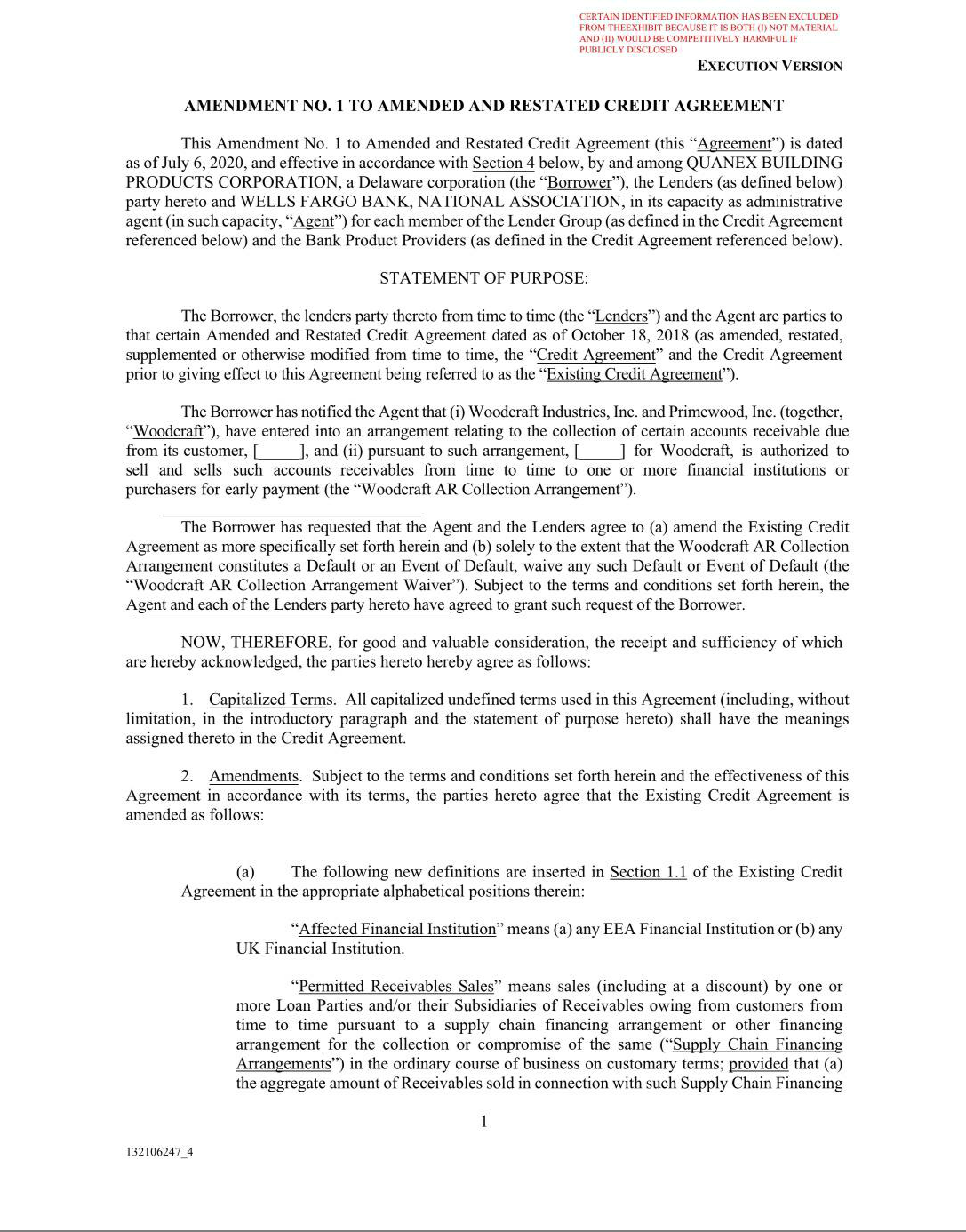

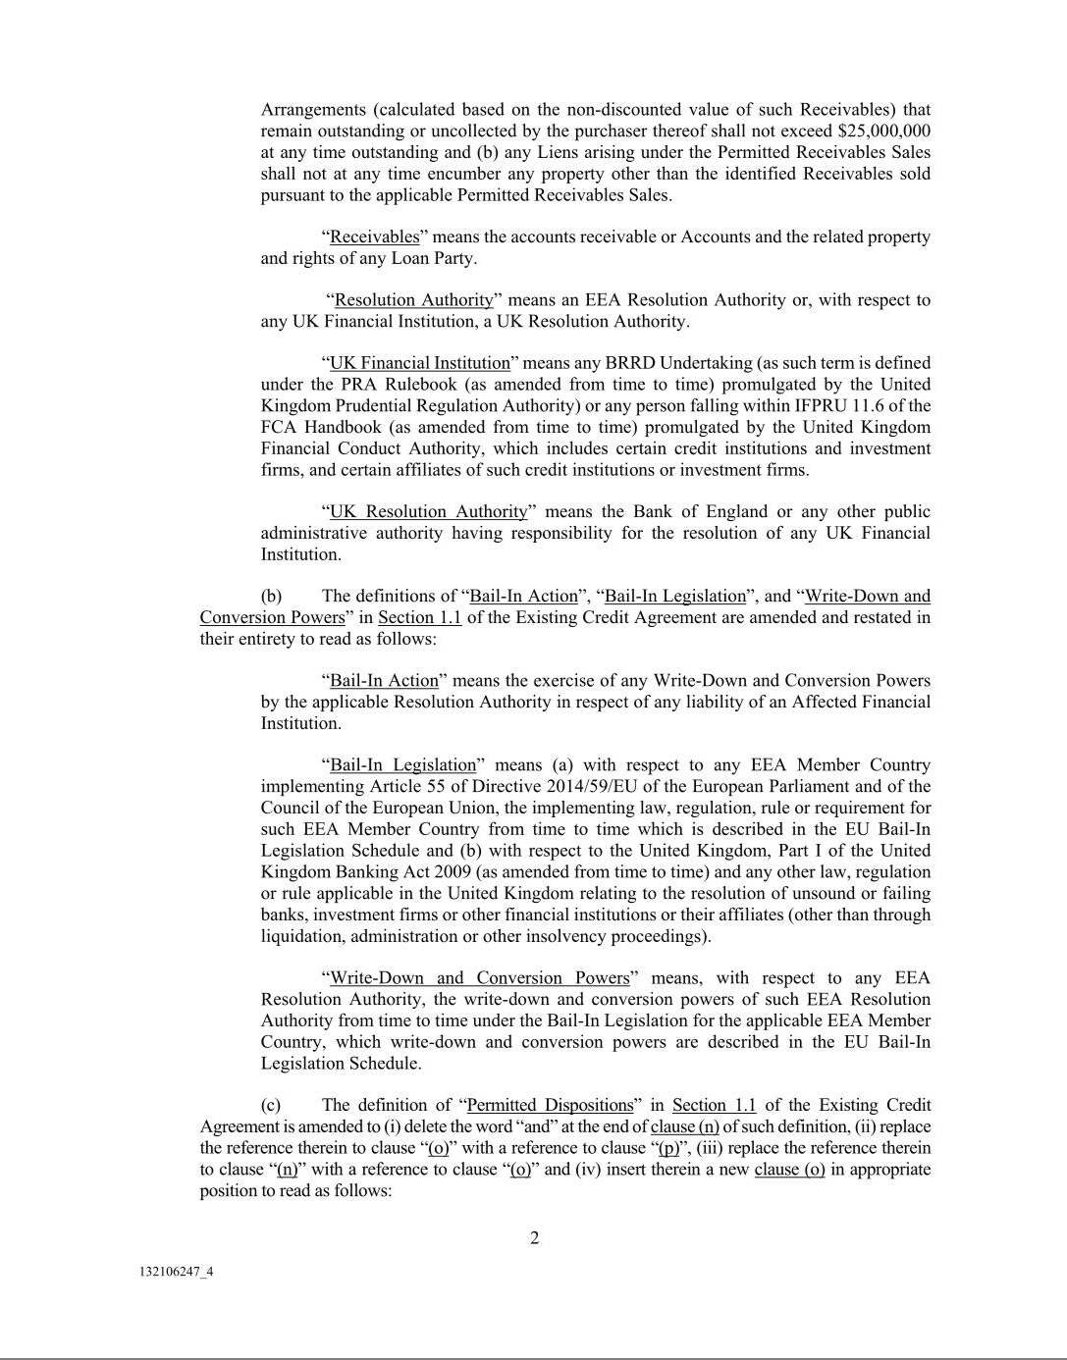

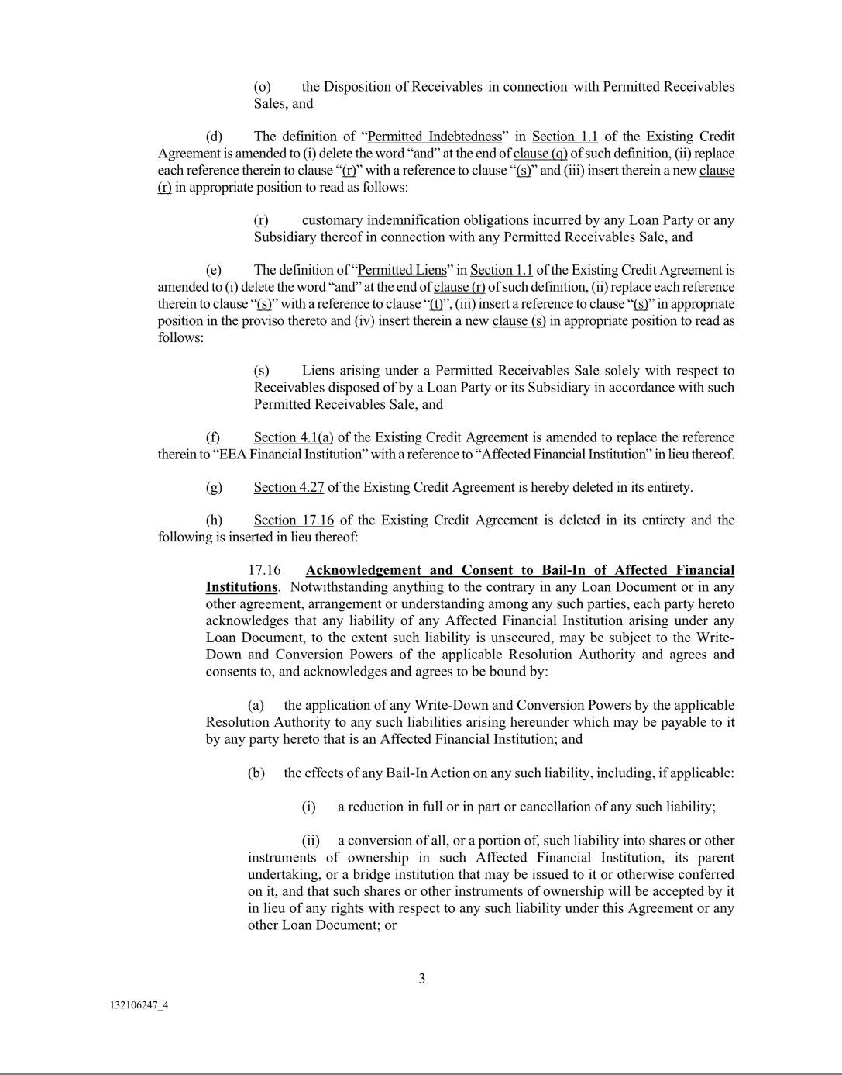

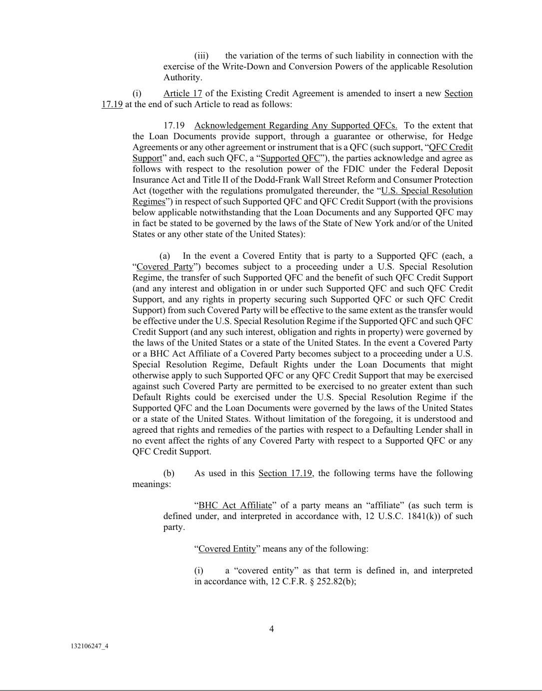

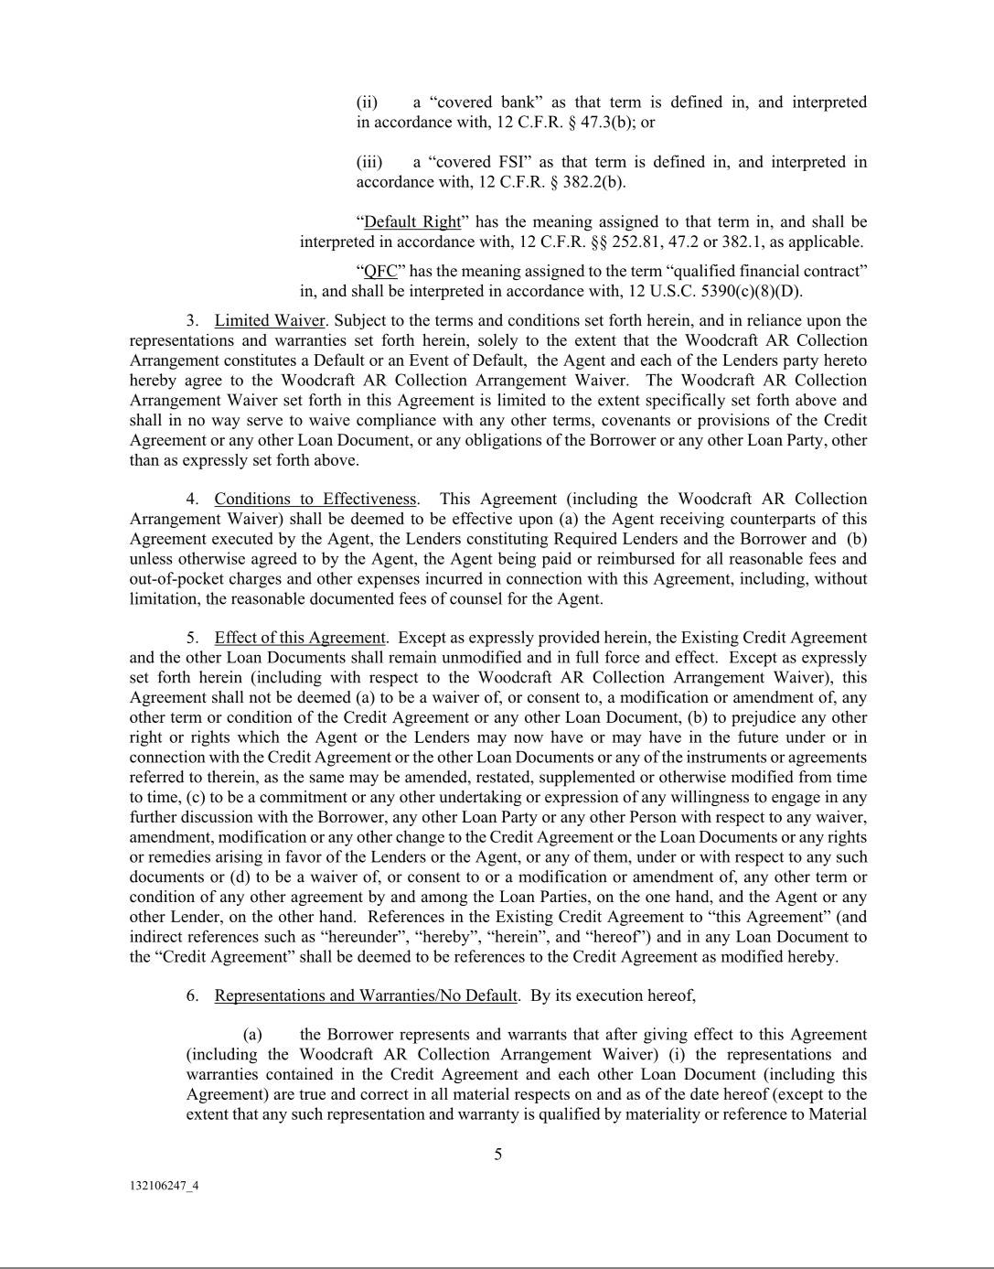

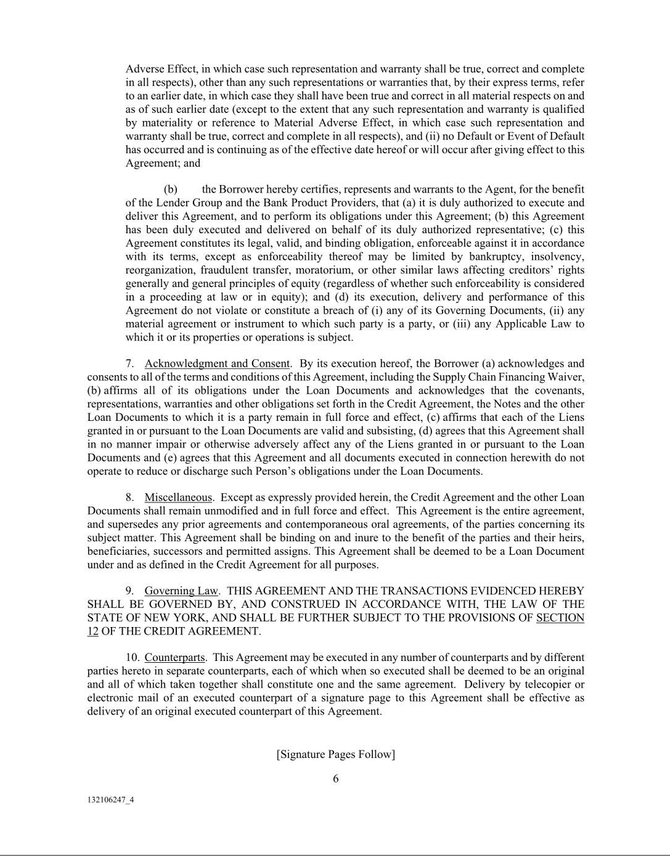

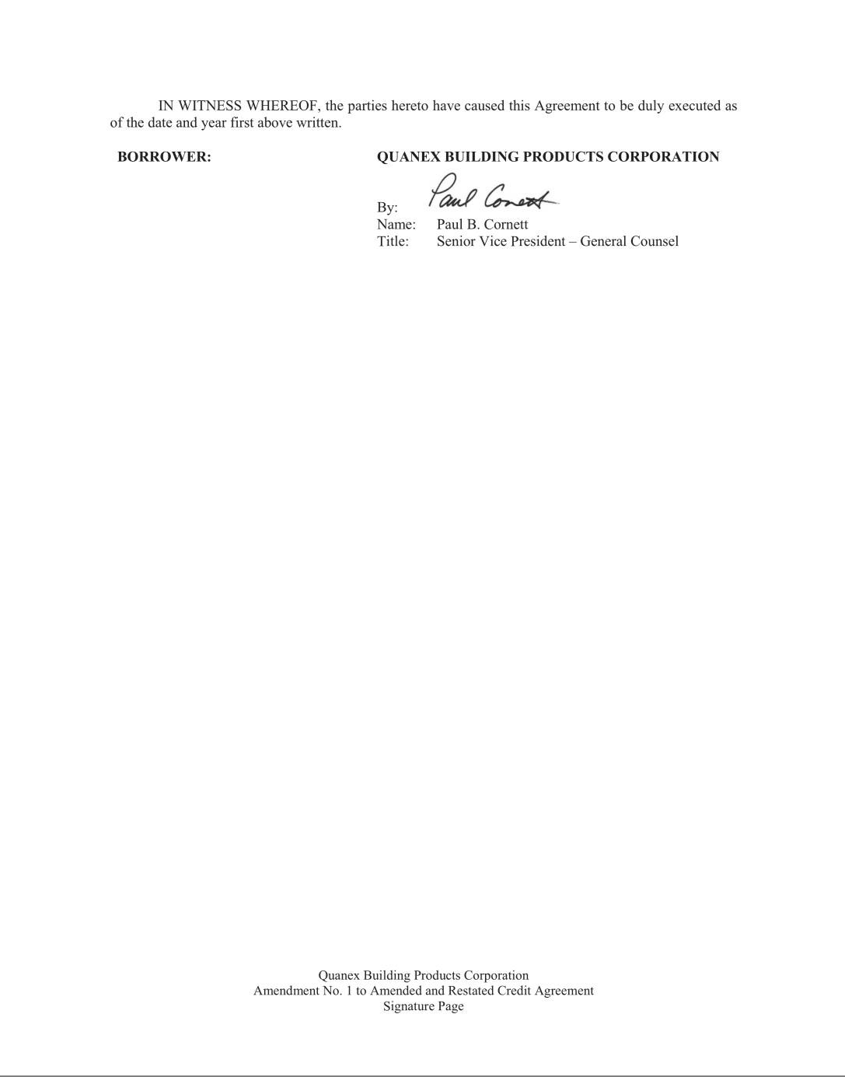

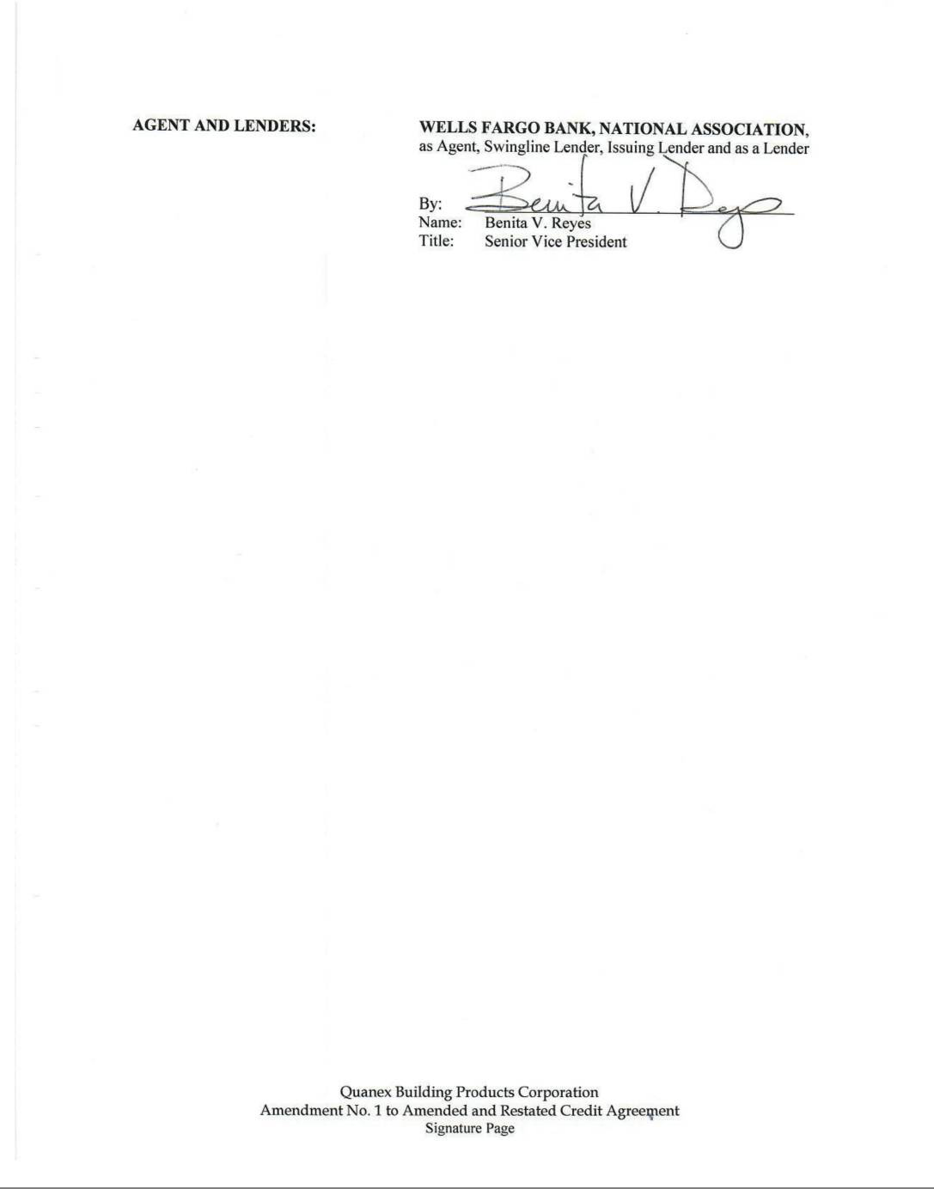





Exhibit 31.1

CHIEF EXECUTIVE OFFICER CERTIFICATION

I, George L. Wilson, certify that:

- I have reviewed this quarterly report on Form 10-Q of Quanex Building Products Corporation (the “Registrant”);

- Based on my knowledge, this report does not contain any untrue statement of a material fact or omit to state a material fact necessary to make the statements made, in light of the circumstances under which such statements were made, not misleading with respect to the period covered by this report;

- Based on my knowledge, the financial statements, and other financial information included in this report, fairly present in all material respects the financial condition, results of operations and cash flows of the Registrant as of, and for, the periods presented in this report;

- The Registrant’s other certifying officer and I are responsible for establishing and maintaining disclosure controls and procedures [as defined in Exchange Act Rules 13a-15(e) and 15d-15(e)] and internal control over financial reporting [as defined in Exchange Act Rules 13a-15(f) and 15d-15(f)] for the Registrant and have:

  - Designed such disclosure controls and procedures, or caused such disclosure controls and procedures to be designed under our supervision, to ensure that material information relating to the Registrant, including its consolidated subsidiaries, is made known to us by others within those entities, particularly during the period in which this report is being prepared;

  - Designed such internal control over financial reporting, or caused such internal control over financial reporting to be designed under our supervision, to provide reasonable assurance regarding the reliability of financial reporting and the preparation of financial statements for external purposes in accordance with generally accepted accounting principles;

  - Evaluated the effectiveness of the Registrant’s disclosure controls and procedures and presented in this report our conclusions about the effectiveness of the disclosure controls and procedures, as of the end of the period covered by this report based on such evaluation; and

  - Disclosed in this report any change in the Registrant’s internal control over financial reporting that occurred during the Registrant’s most recent fiscal quarter (the Registrant’s fourth fiscal quarter in the case of an annual report) that has materially affected, or is reasonably likely to materially affect, the Registrant’s internal control over financial reporting; and

- The Registrant’s other certifying officer and I have disclosed, based on our most recent evaluation of internal control over financial reporting, to the Registrant’s auditors and the audit committee of the Registrant’s board of directors (or persons performing the equivalent functions):

  - All significant deficiencies and material weaknesses in the design or operation of internal control over financial reporting which are reasonably likely to adversely affect the Registrant’s ability to record, process, summarize and report financial information; and

  - Any fraud, whether or not material, that involves management or other employees who have a significant role in the Registrant’s internal control over financial reporting.

September 4, 2020

/s/ George L. Wilson

George L. Wilson

President and Chief Executive Officer

(Principal Executive Officer)

Exhibit 31.2

CHIEF FINANCIAL OFFICER CERTIFICATION

I, Scott M. Zuehlke, certify that:

- I have reviewed this quarterly report on Form 10-Q of Quanex Building Products Corporation (the “Registrant”);

- Based on my knowledge, this report does not contain any untrue statement of a material fact or omit to state a material fact necessary to make the statements made, in light of the circumstances under which such statements were made, not misleading with respect to the period covered by this report;

- Based on my knowledge, the financial statements, and other financial information included in this report, fairly present in all material respects the financial condition, results of operations and cash flows of the Registrant as of, and for, the periods presented in this report;

- The Registrant’s other certifying officer and I are responsible for establishing and maintaining disclosure controls and procedures [as defined in Exchange Act Rules 13a-15(e) and 15d-15(e)] and internal control over financial reporting [as defined in Exchange Act Rules 13a-15(f) and 15d-15(f)] for the Registrant and have:

  - Designed such disclosure controls and procedures, or caused such disclosure controls and procedures to be designed under our supervision, to ensure that material information relating to the Registrant, including its consolidated subsidiaries, is made known to us by others within those entities, particularly during the period in which this report is being prepared;

  - Designed such internal control over financial reporting, or caused such internal control over financial reporting to be designed under our supervision, to provide reasonable assurance regarding the reliability of financial reporting and the preparation of financial statements for external purposes in accordance with generally accepted accounting principles;

  - Evaluated the effectiveness of the Registrant’s disclosure controls and procedures and presented in this report our conclusions about the effectiveness of the disclosure controls and procedures, as of the end of the period covered by this report based on such evaluation; and

  - Disclosed in this report any change in the Registrant’s internal control over financial reporting that occurred during the Registrant’s most recent fiscal quarter (the Registrant’s fourth fiscal quarter in the case of an annual report) that has materially affected, or is reasonably likely to materially affect, the Registrant’s internal control over financial reporting; and

- The Registrant’s other certifying officer and I have disclosed, based on our most recent evaluation of internal control over financial reporting, to the Registrant’s auditors and the audit committee of the Registrant’s board of directors (or persons performing the equivalent functions):

  - All significant deficiencies and material weaknesses in the design or operation of internal control over financial reporting which are reasonably likely to adversely affect the Registrant’s ability to record, process, summarize and report financial information; and

  - Any fraud, whether or not material, that involves management or other employees who have a significant role in the Registrant’s internal control over financial reporting.

September 4, 2020

/s/ Scott M. Zuehlke

Scott M. Zuehlke

Senior Vice President - Chief Financial Officer and Treasurer

(Principal Financial Officer)

Exhibit 32.1

Certification Pursuant To Section 906 of the Sarbanes-Oxley Act of 2002

We hereby certify that the accompanying Quarterly Report on Form 10-Q of Quanex Building Products Corporation for the quarter ended July 31, 2020 fully complies with the requirements of Section 13(a) or 15(d) of the Securities Exchange Act of 1934 and that information contained in such Report fairly presents, in all material respects, the financial condition and results of operations of Quanex Building Products Corporation.

September 4, 2020

/s/ George L. Wilson |  | /s/ Scott M. Zuehlke
George L. Wilson |  | Scott M. Zuehlke
President and Chief Executive Officer |  | Senior Vice President—Chief Financial Officer and Treasurer
(Principal Executive Officer) |  | (Principal Financial Officer)

